# **Supplemental Figures**

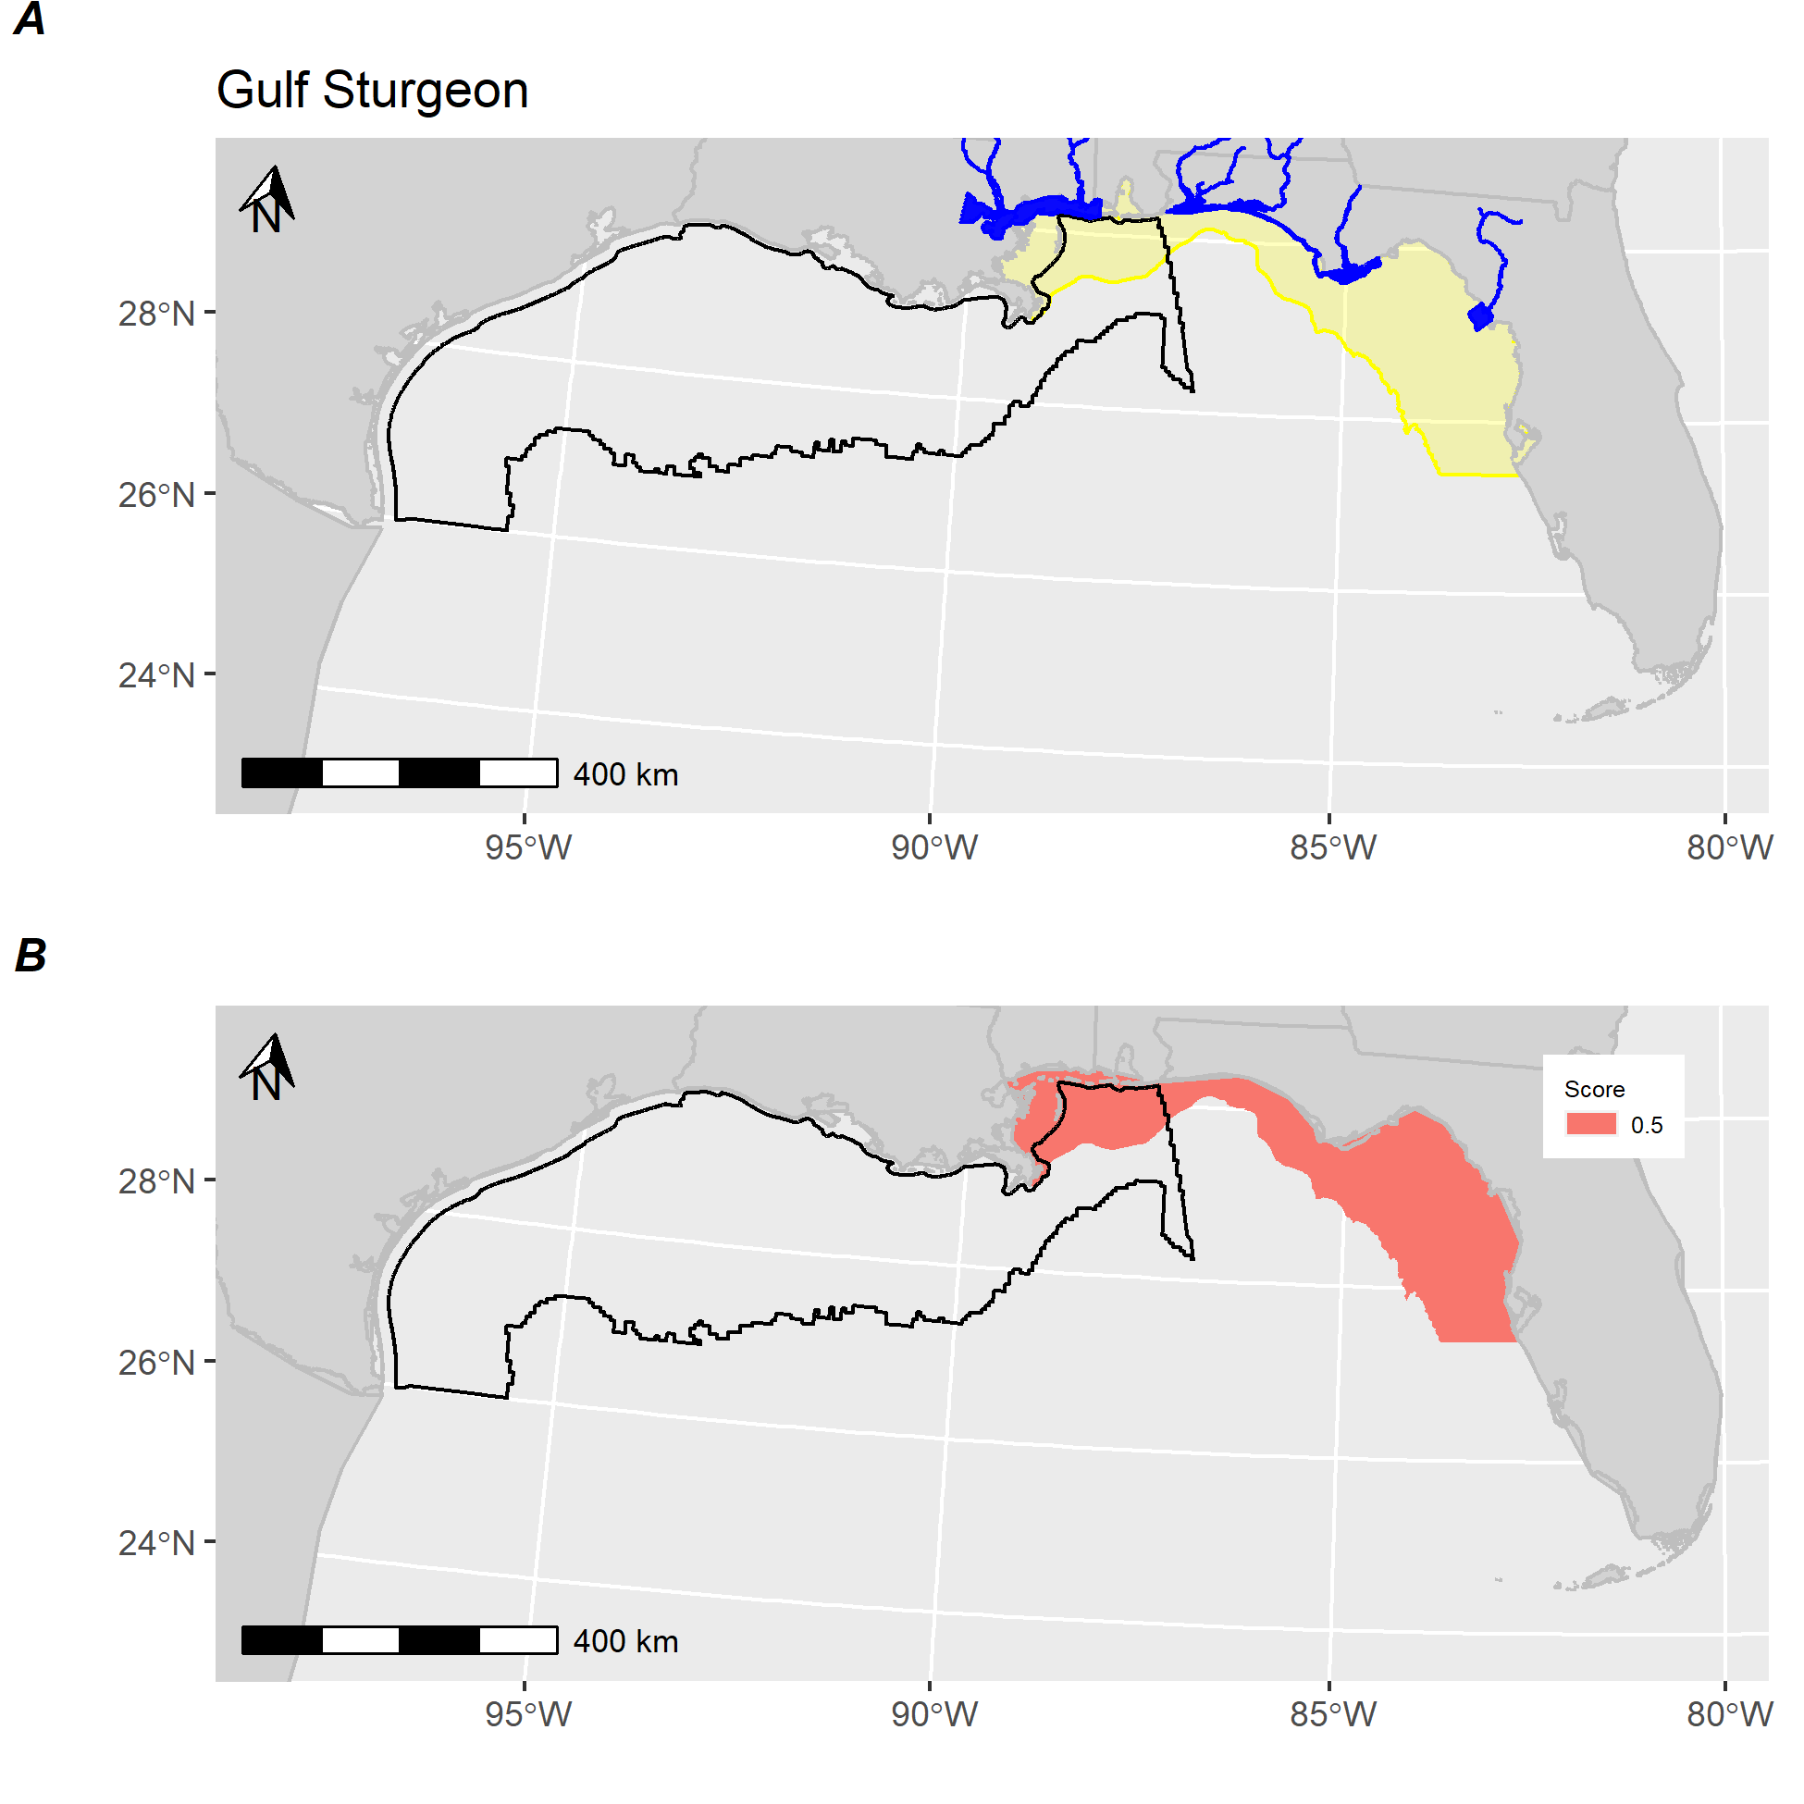

**Figure S-A.** *Gulf sturgeon distribution and score.* A) Section 7 consultation layer (yellow) and defined critical habitat (blue) for Gulf sturgeon. B) Calculated score for Gulf sturgeon showing areas receiving a score. Black polygon denotes Gulf of Mexico wind energy Call Area.

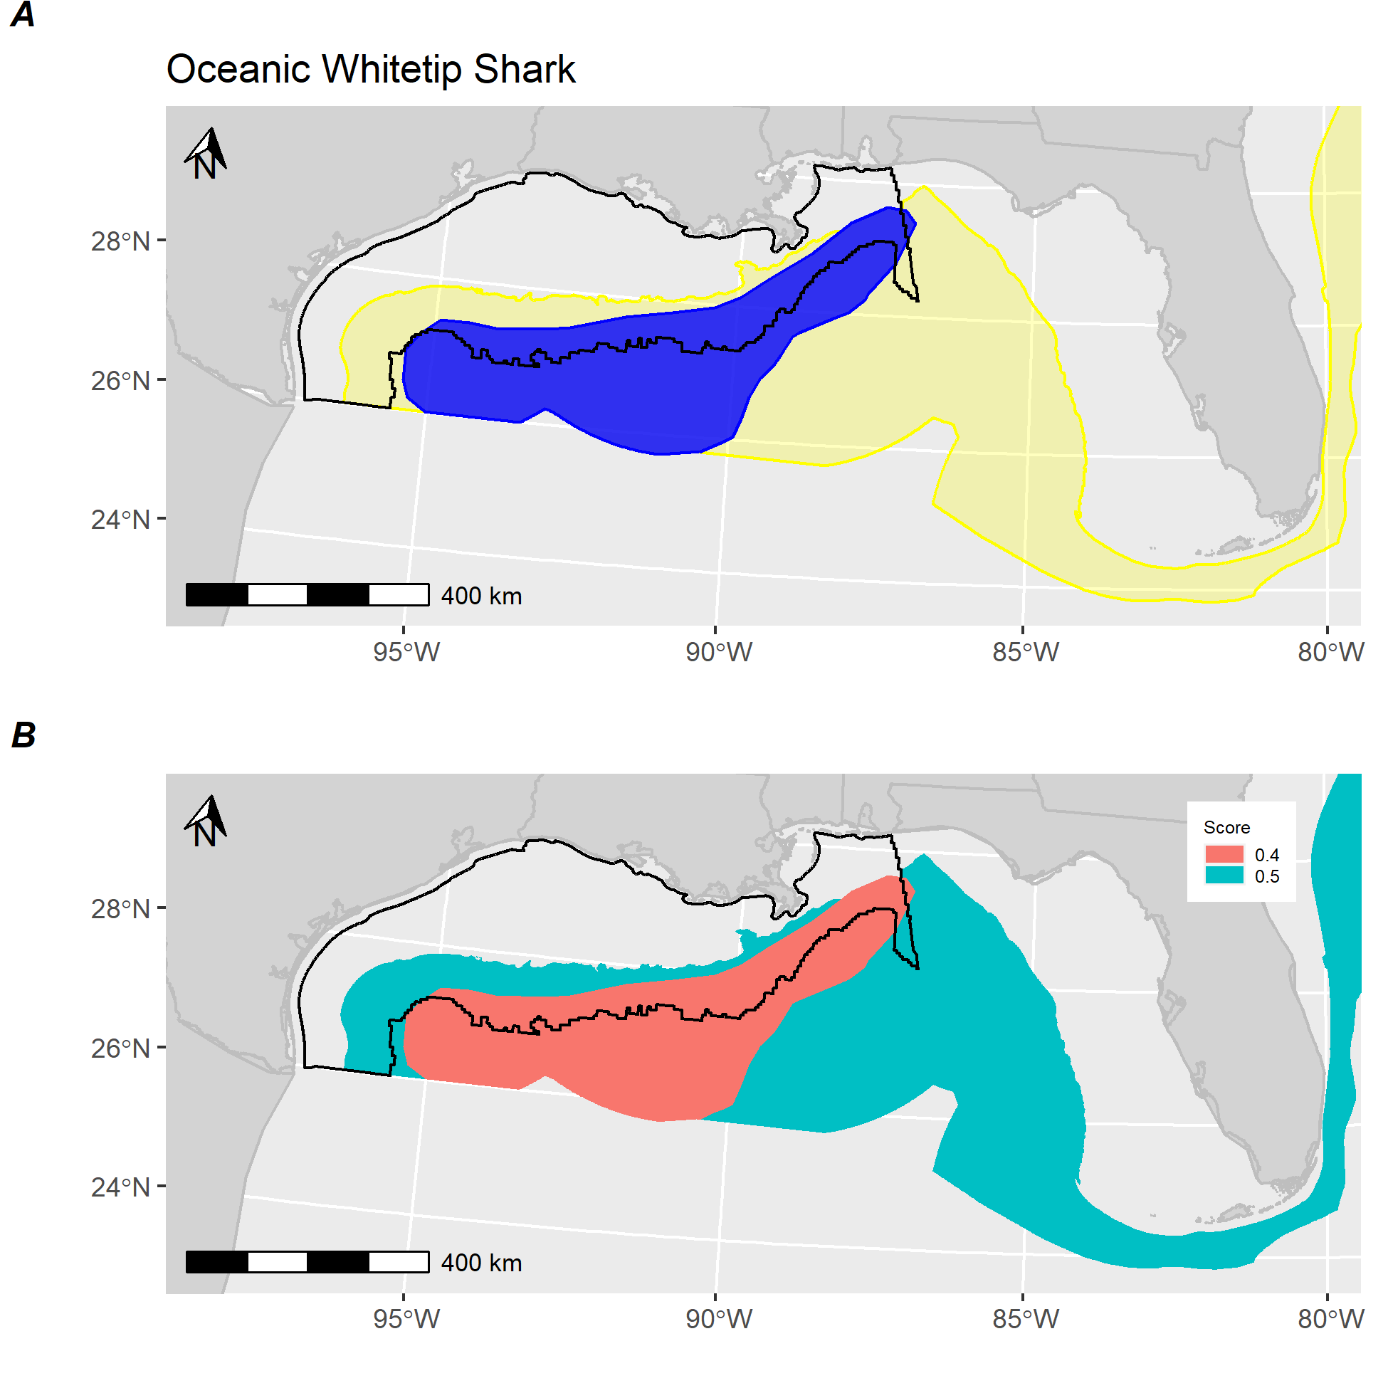

**Figure S-B.** *Oceanic whitetip distribution and score.* A) Section 7 consultation layer (yellow) and defined essential fish habitat (blue) for Oceanic whitetip shark. B) Calculated score for Oceanic whitetip shark showing areas receiving a score. Black polygon denotes Gulf of Mexico wind energy Call Area.

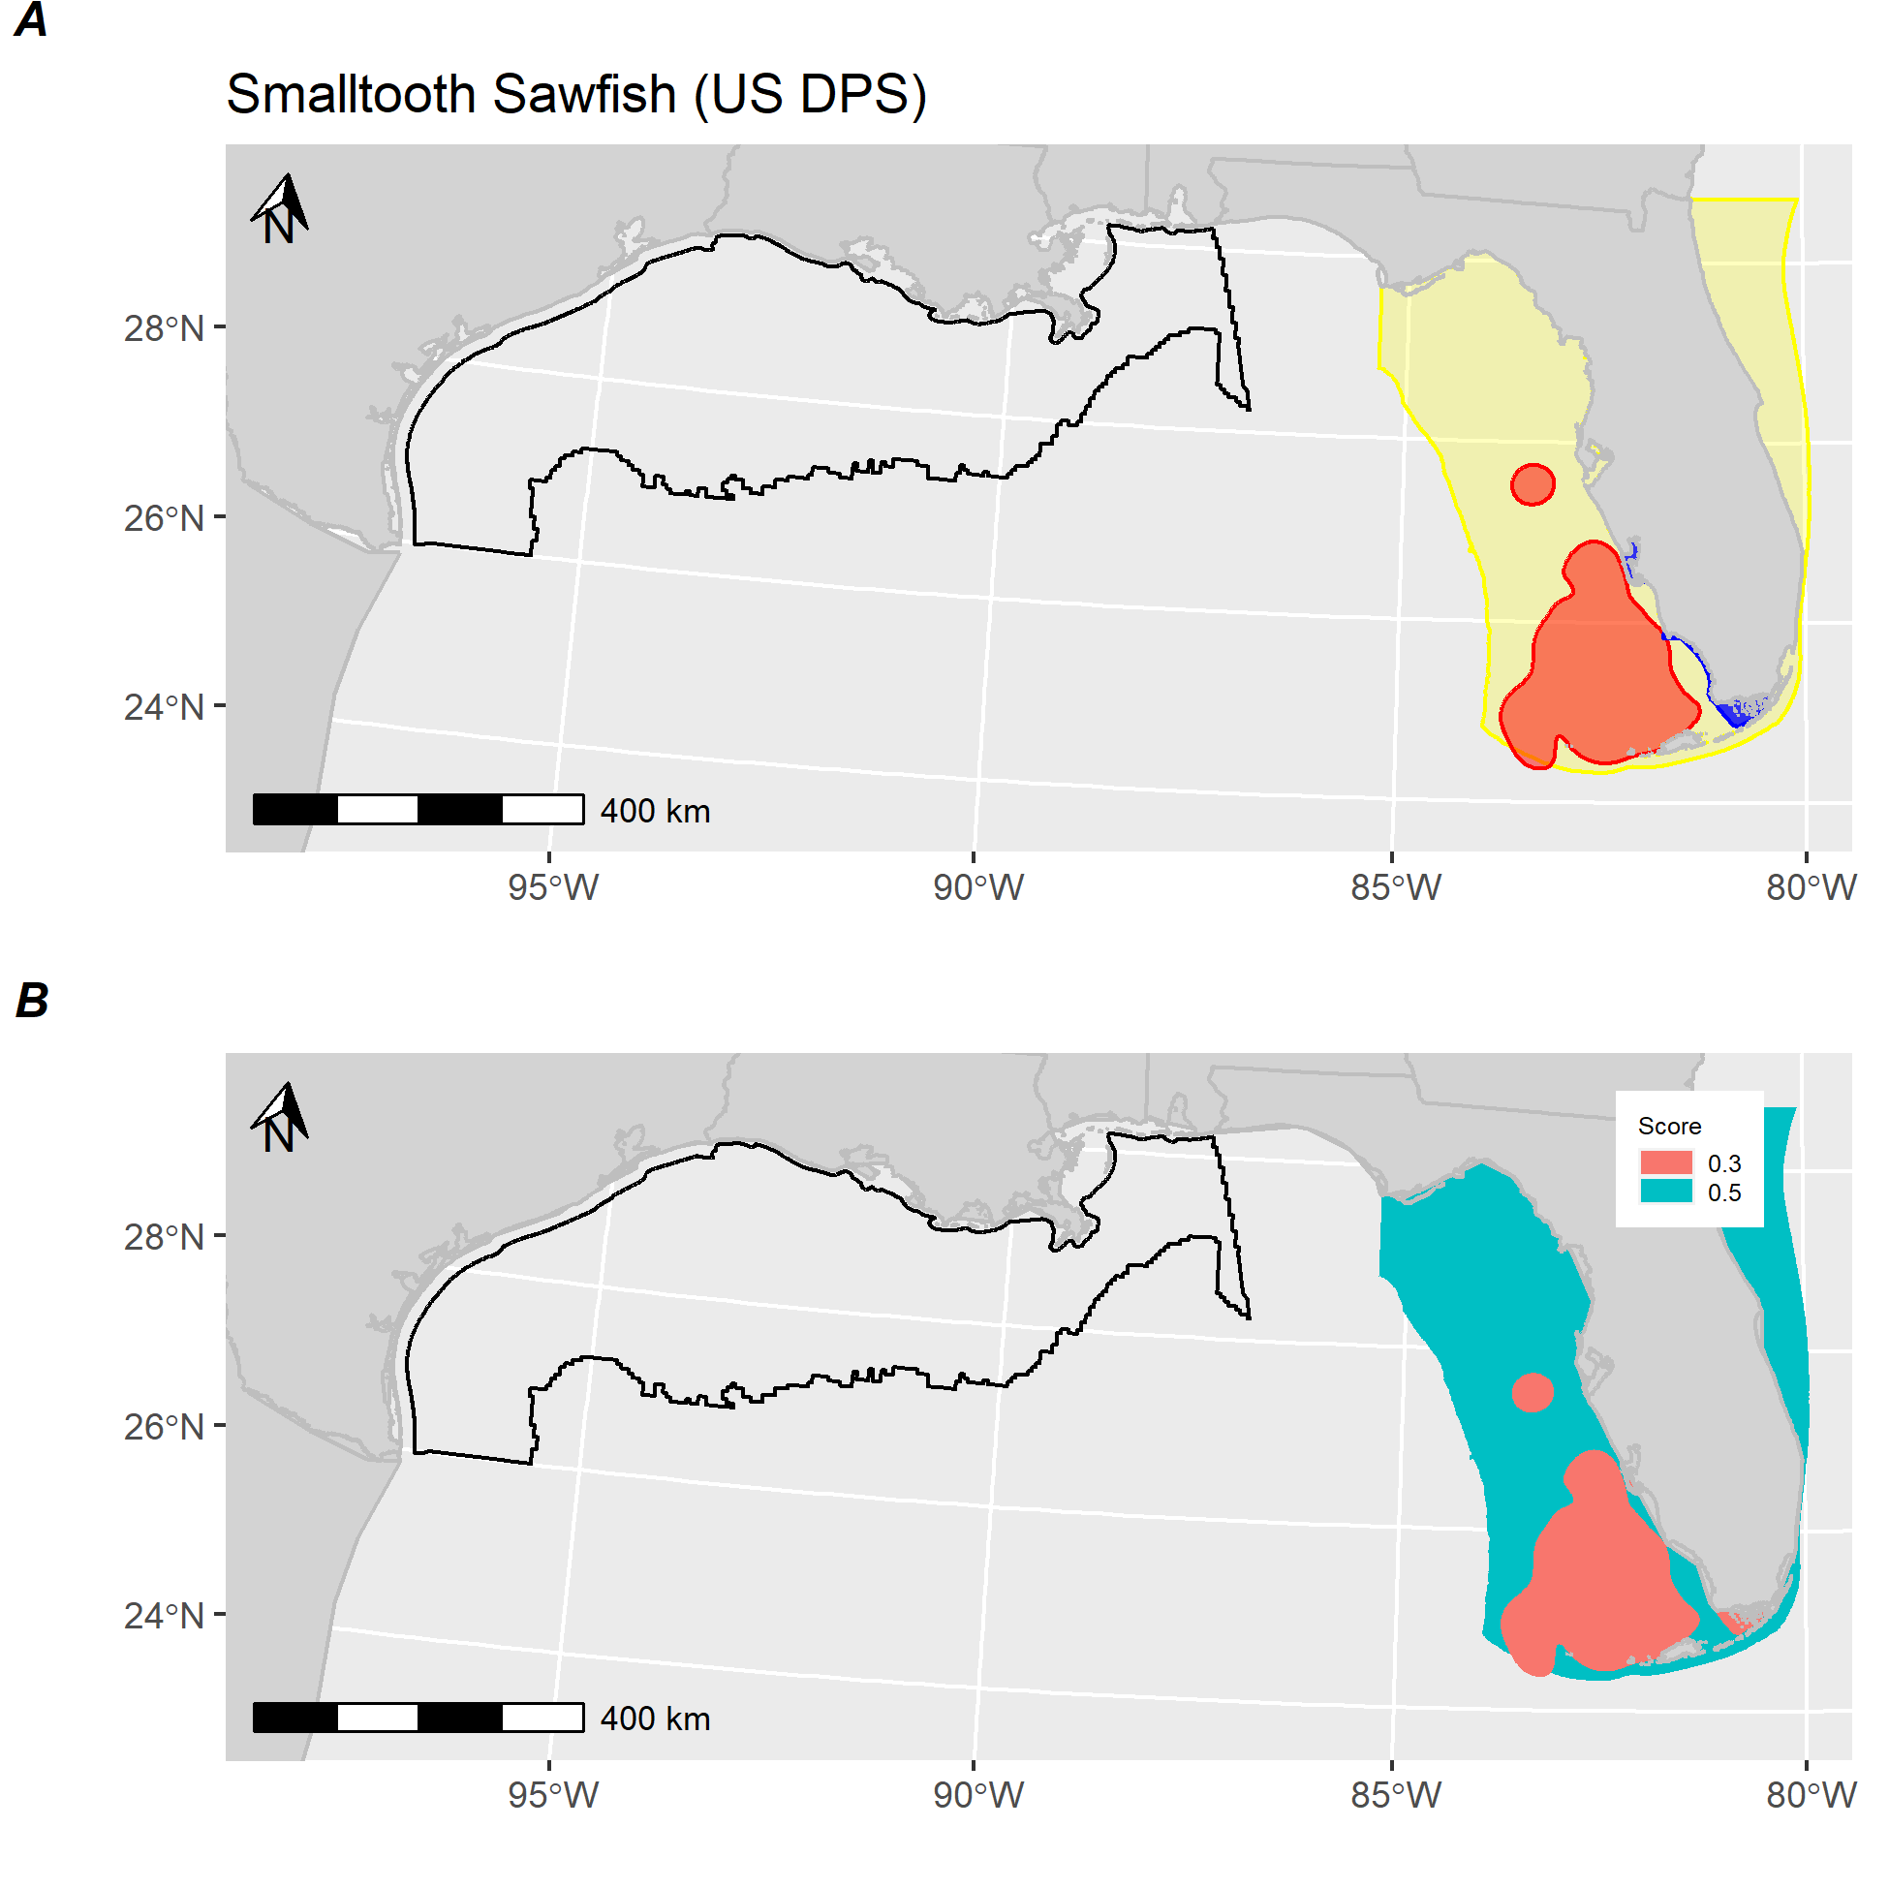

**Figure 1C.** *Smalltooth sawfish (US DPS) distribution and score.* A) High-use area (red), critical habitat (blue), and Section 7 consultation layer (yellow) for Smalltooth sawfish (US DPS). B) Calculated score for Smalltooth sawfish (US DPS) showing areas receiving a score. Black polygon denotes Gulf of Mexico wind energy Call Area.

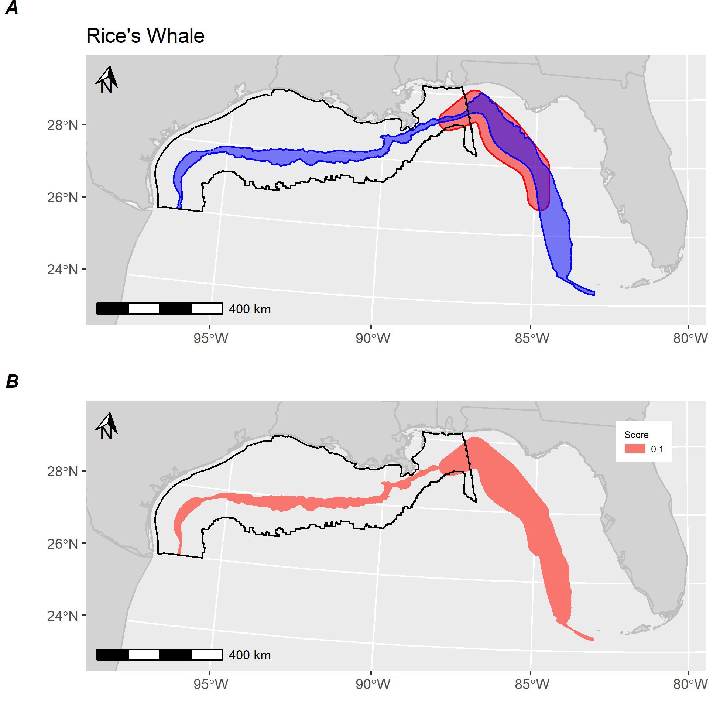

**Figure S-D.** *Rice’s whale distribution and score.* A) Core area (red) and suitable habitat (blue) for Rice’s whale. B) Calculated score for Rice’s whale showing areas receiving a score. Black polygon denotes Gulf of Mexico wind energy Call Area.

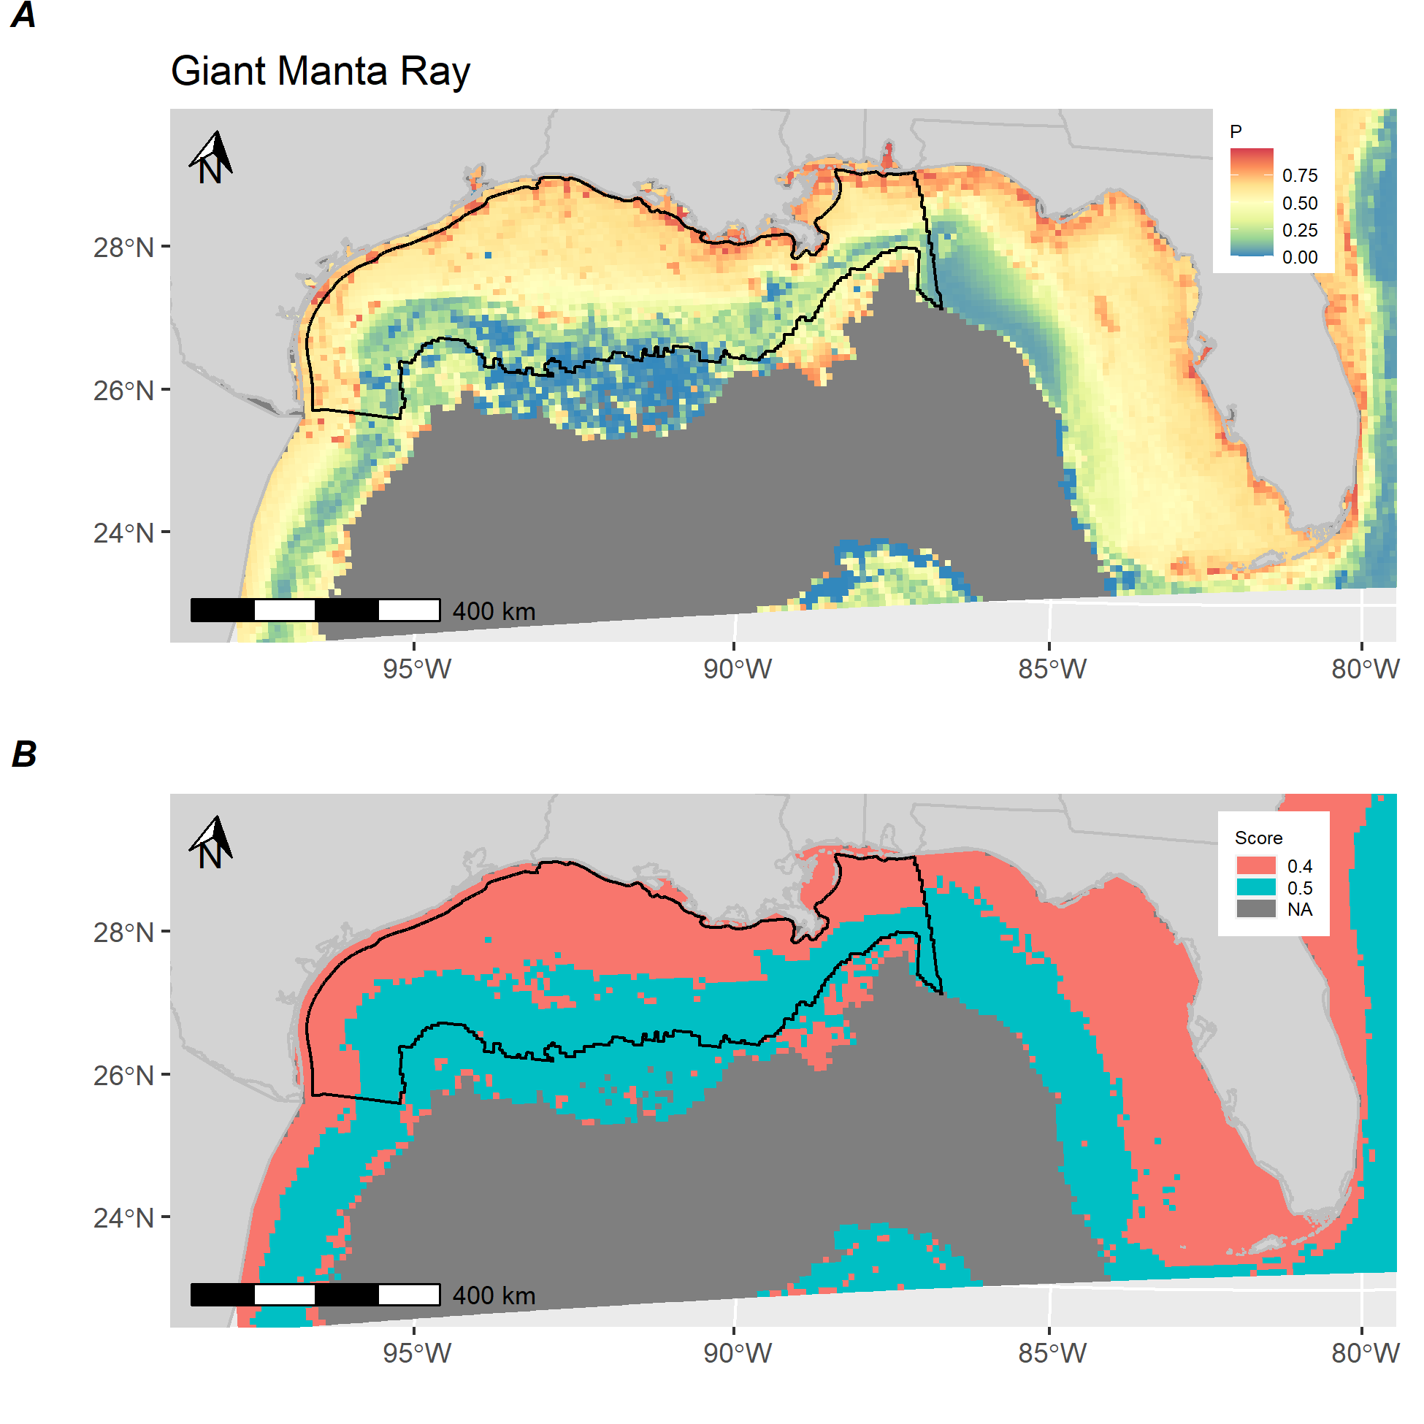

**Figure S-E.** *Giant manta ray distribution and score.* A) Estimated maximum probability of occurrence for Giant manta ray in the Gulf of Mexico based on a species distribution model fit to distance-weighted aerial survey with environmental and bathymetric covariates from Jan 2003–Dec 2019. B) Calculated score for Giant manta ray showing areas above (red) and below (blue) median predictions from distribution model. Black polygon denotes Gulf of Mexico wind energy Call Area.

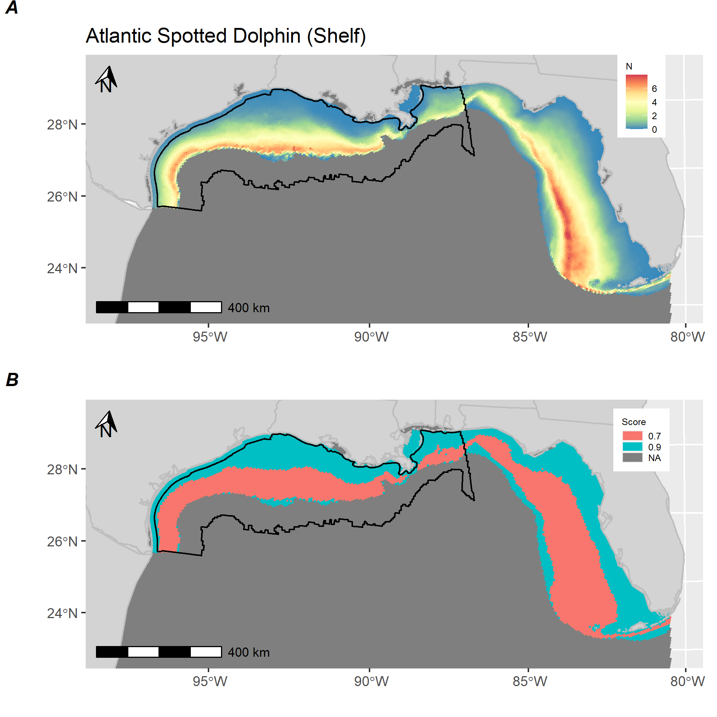

**Figure S-F.** *Atlantic spotted dolphin (shelf) distribution and score.* A) Estimated abundance of Atlantic spotted dolphin (shelf) in the Gulf of Mexico based on a species distribution model fit to distance-weighted aerial survey with environmental and bathymetric covariates. B) Calculated score for Atlantic spotted dolphin (shelf) showing areas above (red) and below (blue) median predictions from distribution model. Black polygon denotes Gulf of Mexico wind energy Call Area.

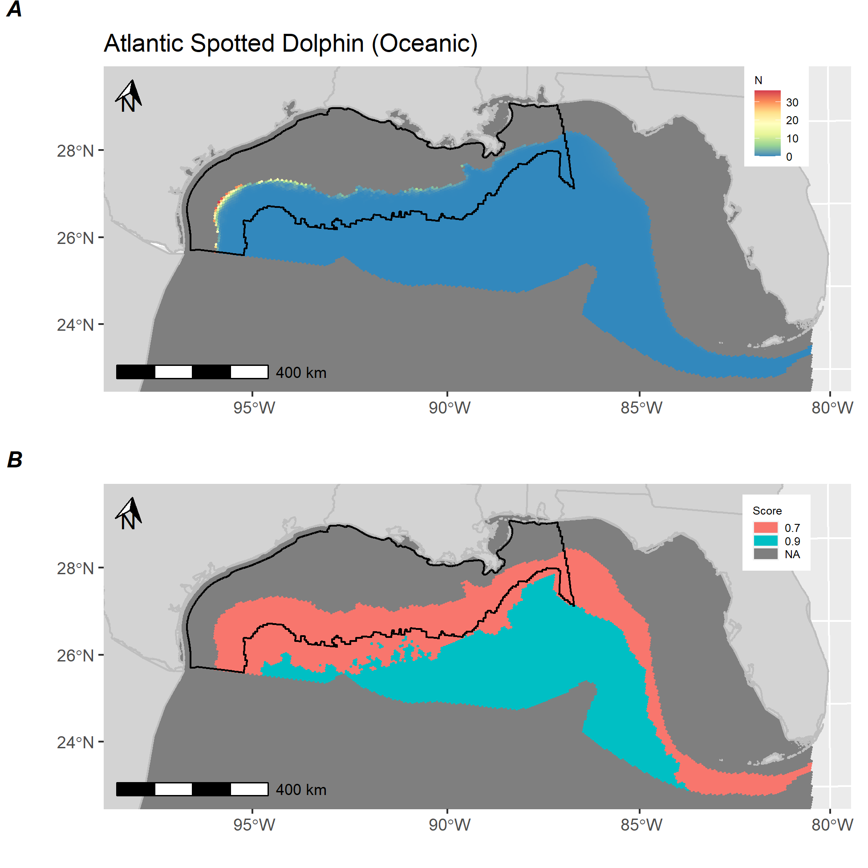

**Figure S-G.** *Atlantic spotted dolphin (oceanic) distribution and score.* A) Estimated abundance of Atlantic spotted dolphin (oceanic) in the Gulf of Mexico based on a species distribution model fit to distance-weighted vessel survey with environmental and bathymetric covariates. B) Calculated score for Atlantic spotted dolphin (oceanic) showing areas above (red) and below (blue) median predictions from distribution model. Black polygon denotes Gulf of Mexico wind energy Call Area.

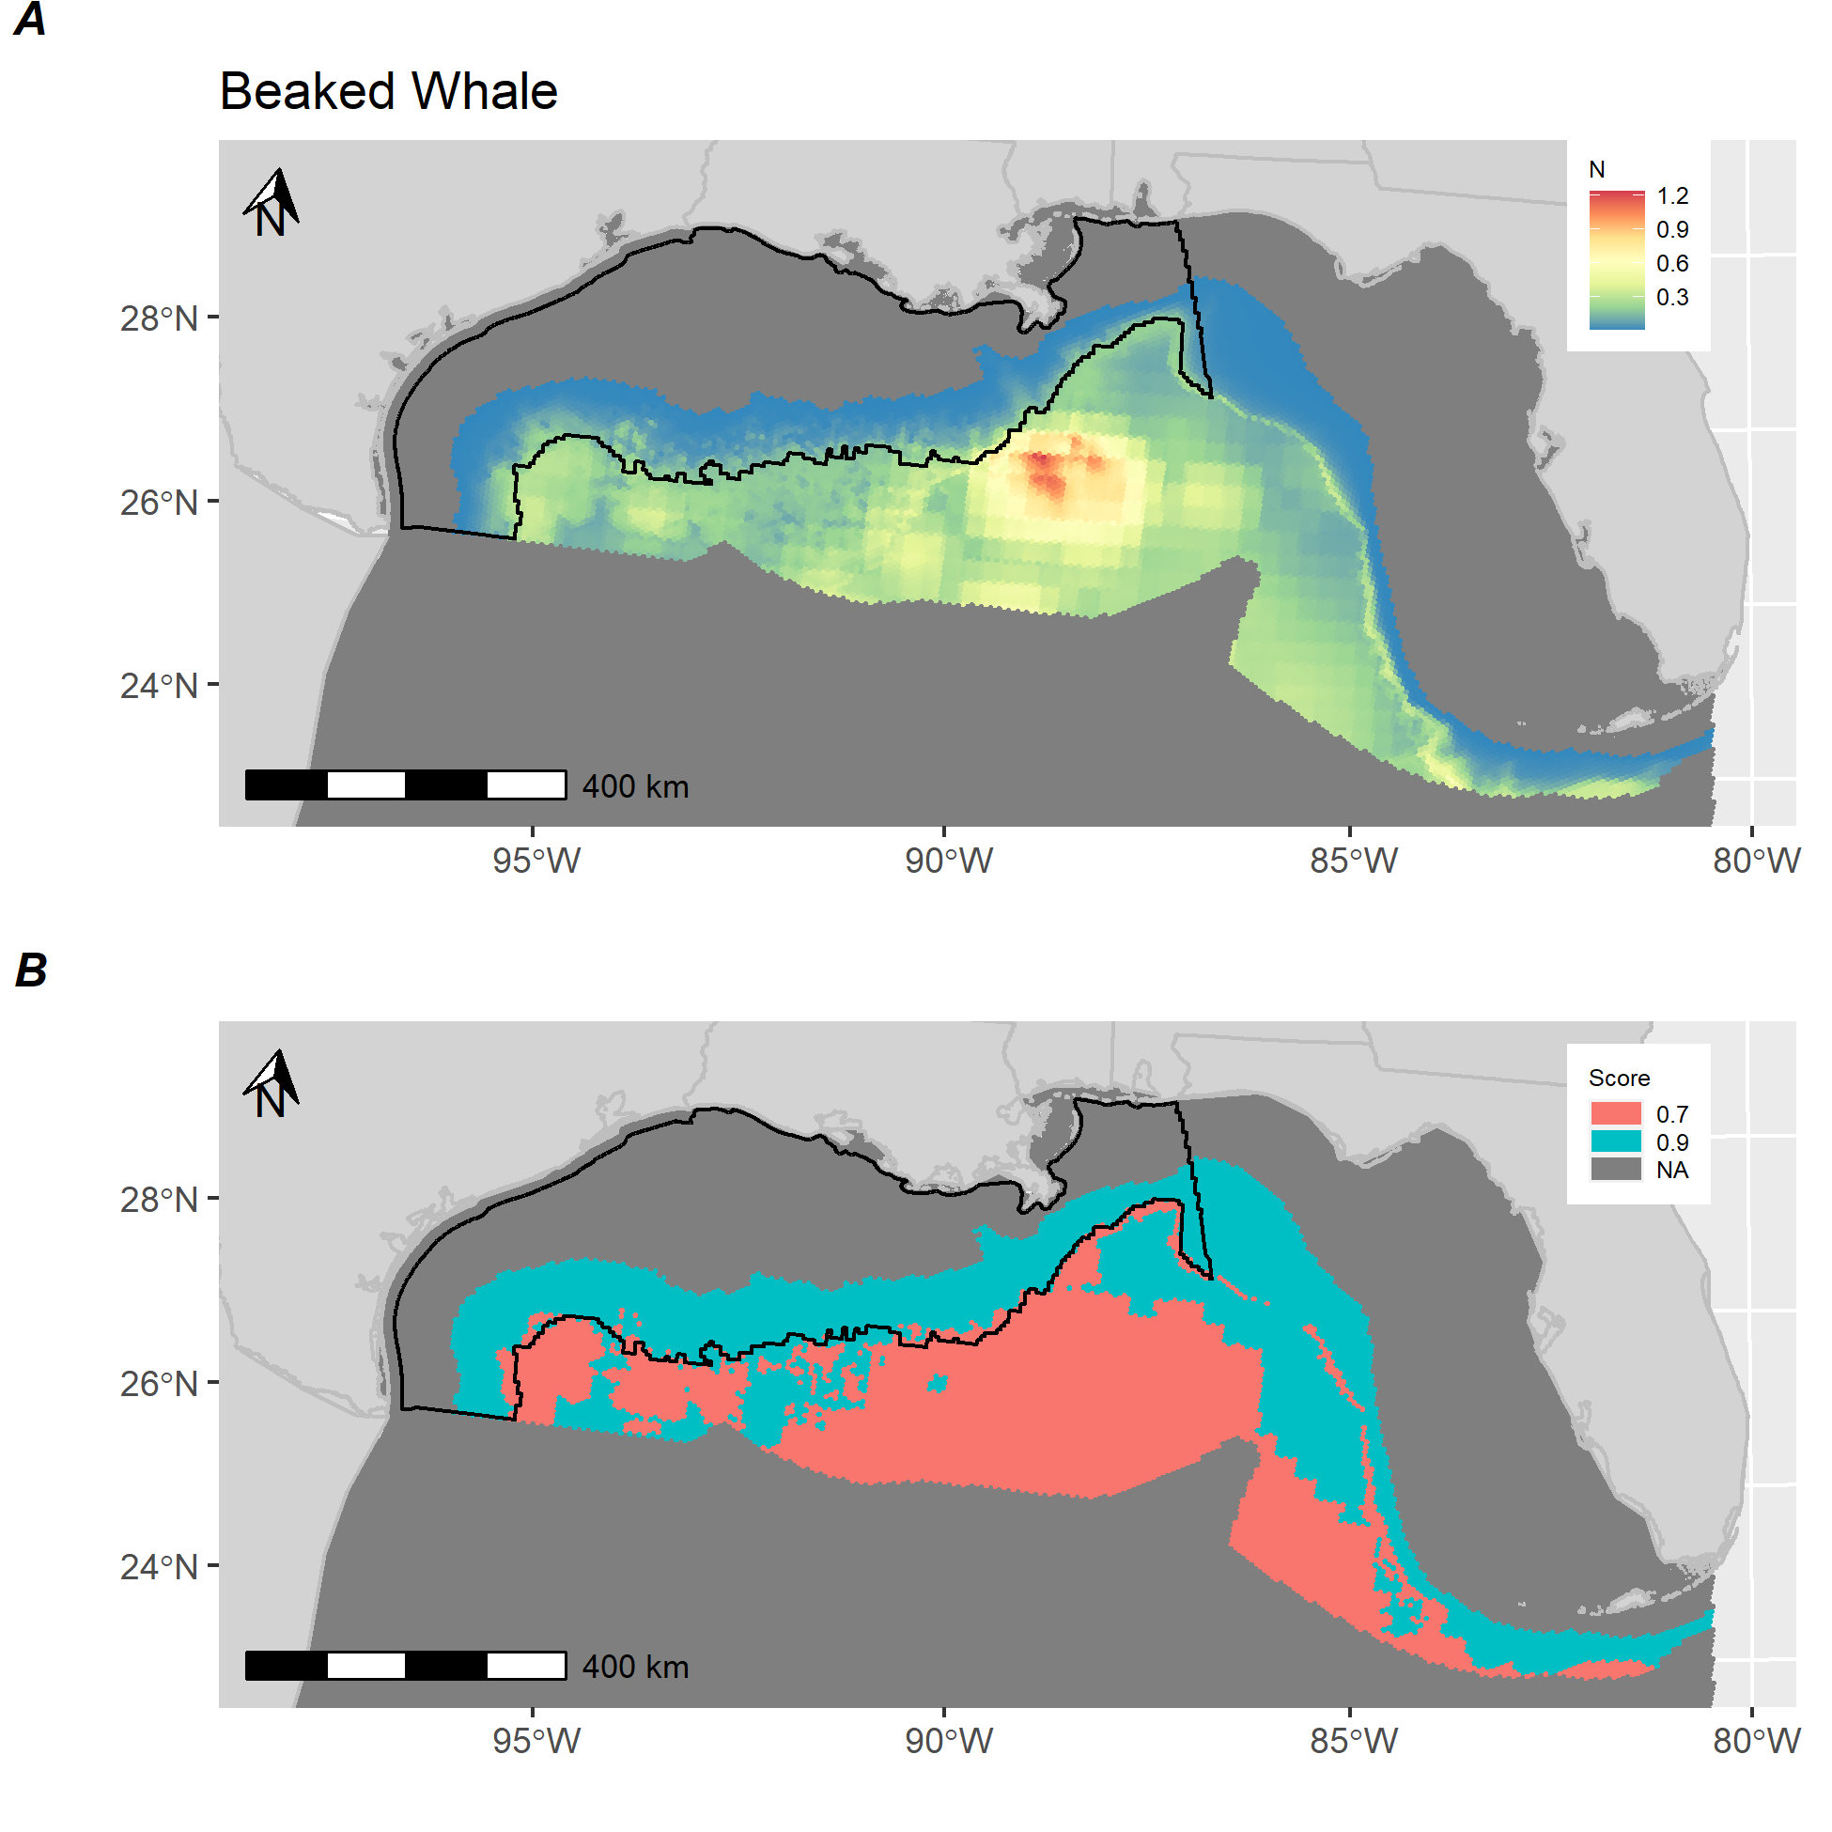

**Figure S-H.** *Beaked whale distribution and score.* A) Estimated abundance of beaked whales in the Gulf of Mexico based on a species distribution model fit to distance-weighted vessel survey with environmental and bathymetric covariates. B) Calculated score for beaked whales showing areas above (red) and below (blue) median predictions from distribution model. Black polygon denotes Gulf of Mexico wind energy Call Area.

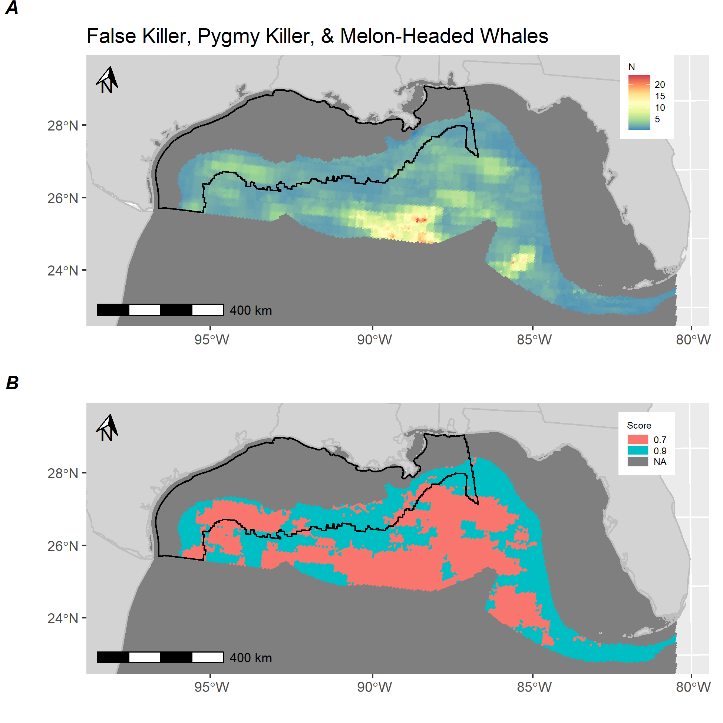

**Figure S-I.** *Blackfish (False killer, pygmy killer, and melon-headed whale) distribution and score.* A) Estimated abundance of blackfish in the Gulf of Mexico based on a species distribution model fit to distance-weighted vessel survey with environmental and bathymetric covariates. B) Calculated score for blackfish showing areas above (red) and below (blue) median predictions from distribution model. Black polygon denotes Gulf of Mexico wind energy Call Area.

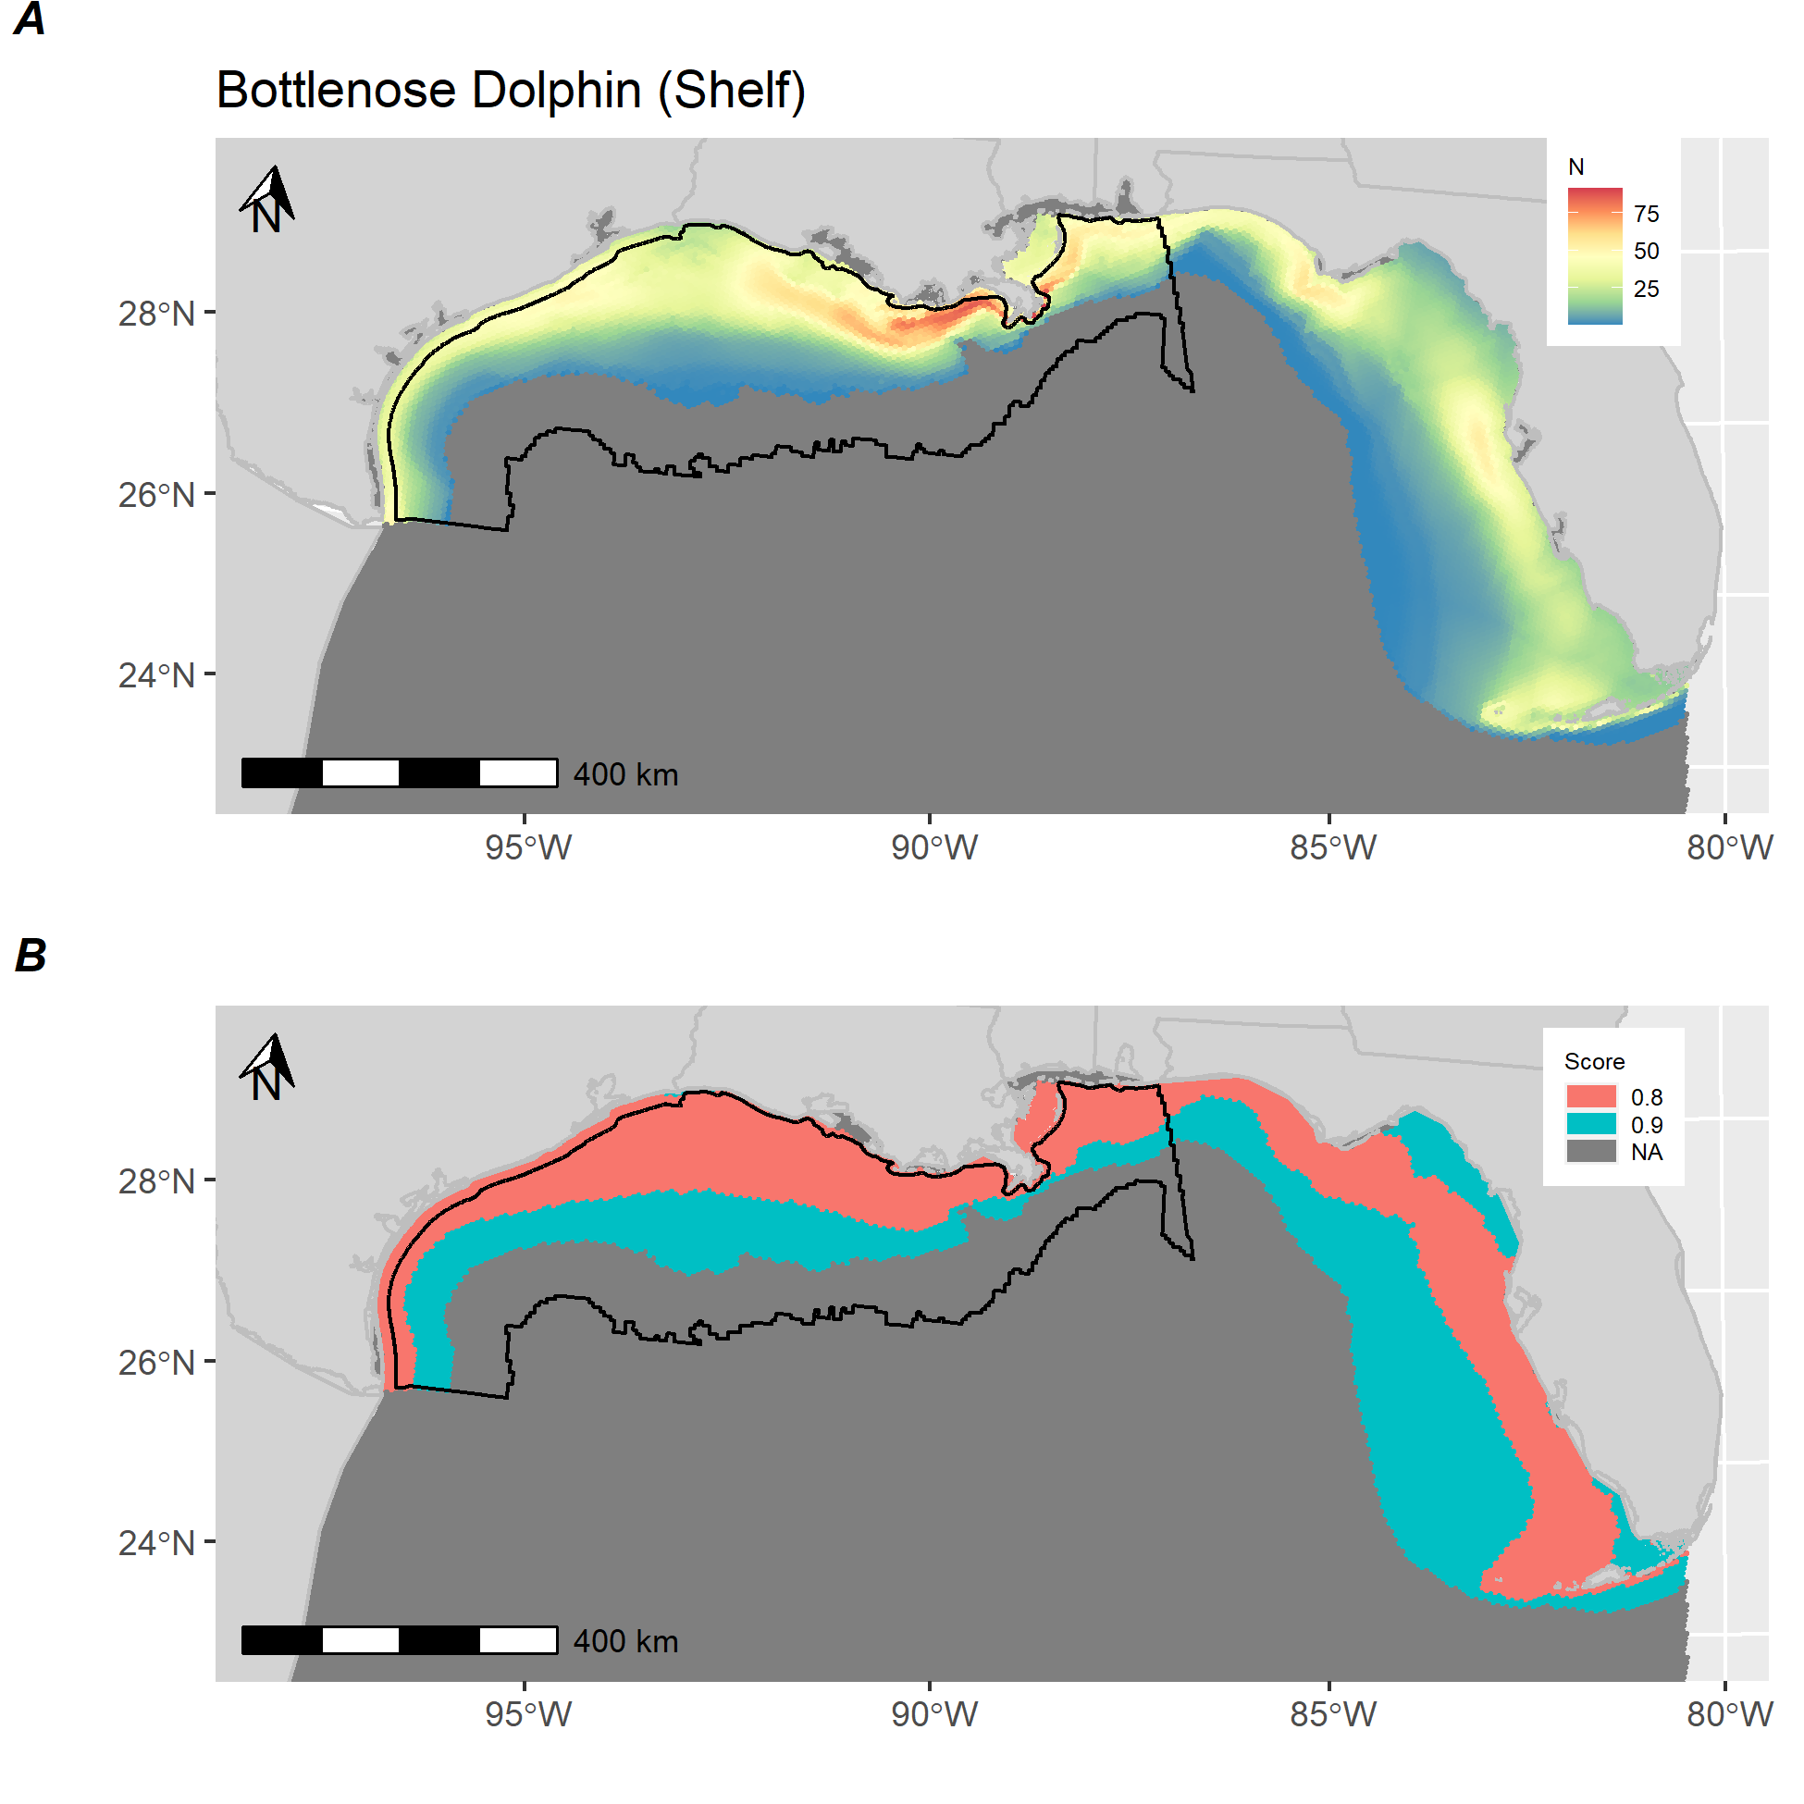

**Figure S-J.** *Bottlenose dolphin (shelf) distribution and score.* A) Estimated abundance of Bottlenose dolphin (shelf) in the Gulf of Mexico based on a species distribution model fit to distance-weighted aerial survey with environmental and bathymetric covariates. B) Calculated score for Bottlenose dolphin (shelf) showing areas above (red) and below (blue) median predictions from distribution model. Black polygon denotes Gulf of Mexico wind energy Call Area.

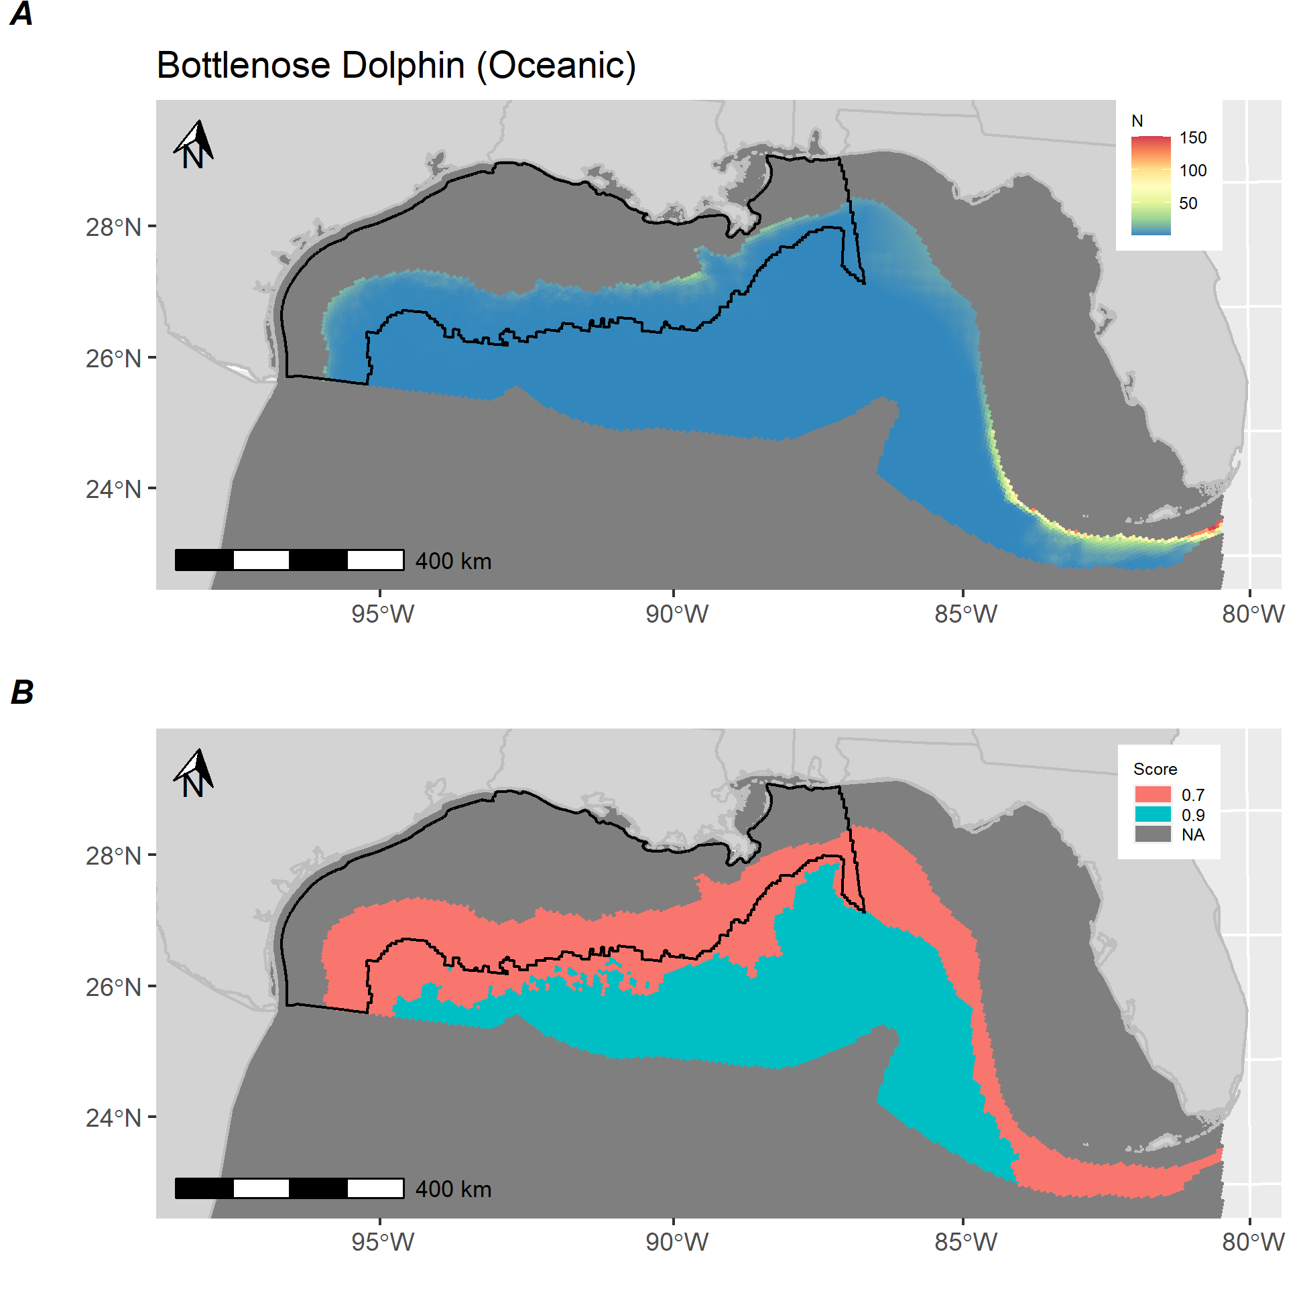

**Figure S-K.** *Bottlenose dolphin (oceanic) distribution and score.* A) Estimated abundance of Bottlenose dolphin (oceanic) in the Gulf of Mexico based on a species distribution model fit to distance-weighted vessel survey with environmental and bathymetric covariates. B) Calculated score for Bottlenose dolphin (oceanic) showing areas above (red) and below (blue) median predictions from distribution model. Black polygon denotes Gulf of Mexico wind energy Call Area.

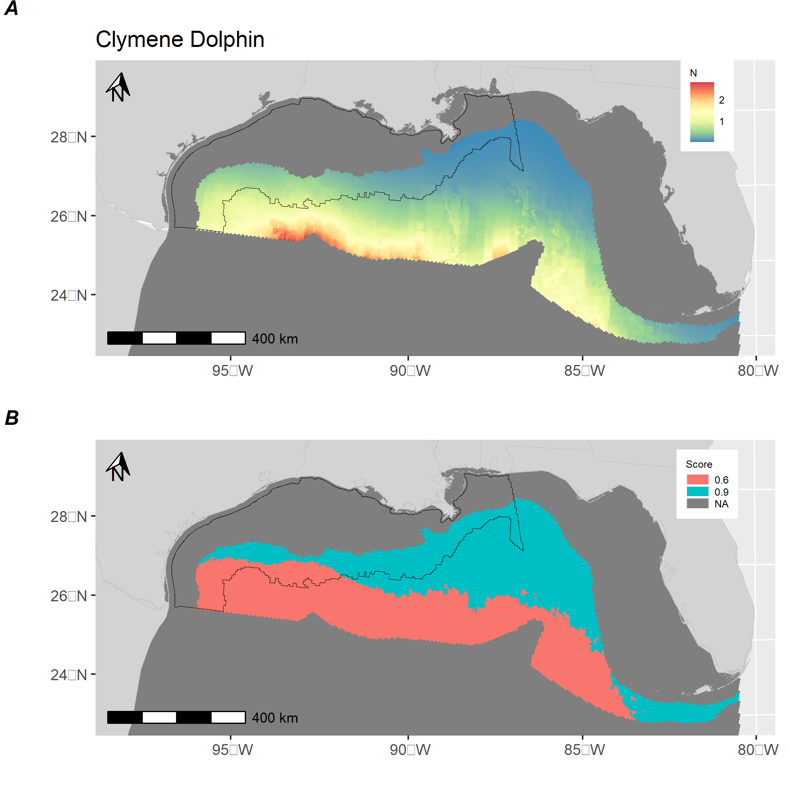

**Figure S-L.** *Clymene dolphin distribution and score.* A) Estimated abundance of Clymene dolphin in the Gulf of Mexico based on a species distribution model fit to distance-weighted vessel survey with environmental and bathymetric covariates. B) Calculated score for Clymene dolphin showing areas above (red) and below (blue) median predictions from distribution model. Black polygon denotes Gulf of Mexico wind energy Call Area.

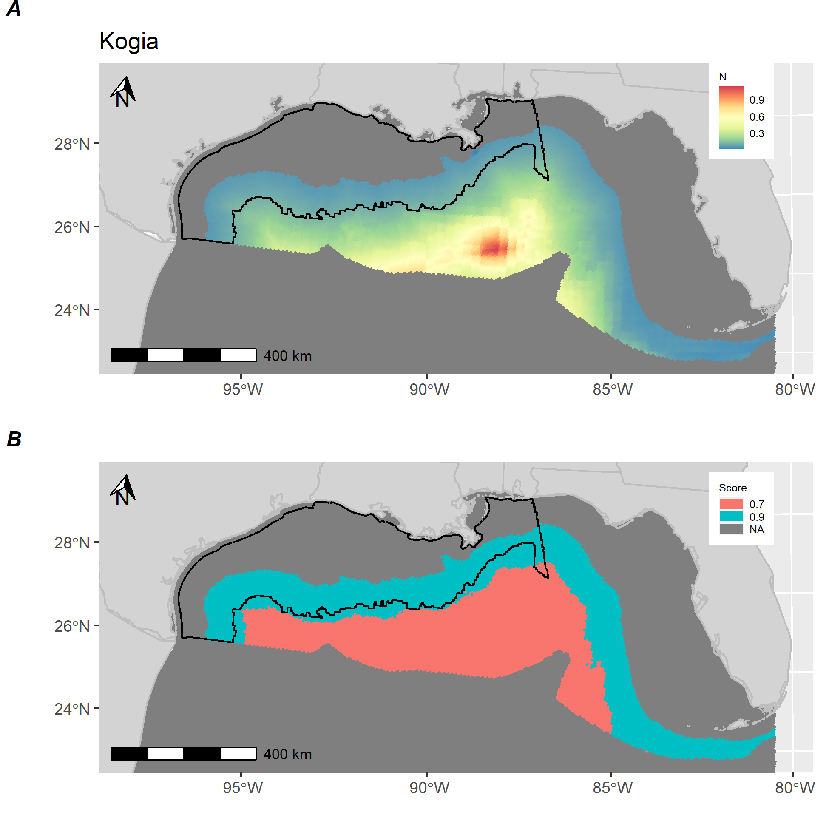

**Figure S-M.** *Kogia distribution and score.* A) Estimated abundance of Kogia in the Gulf of Mexico based on a species distribution model fit to distance-weighted vessel survey with environmental and bathymetric covariates. B) Calculated score for Kogia showing areas above (red) and below (blue) median predictions from distribution model. Black polygon denotes Gulf of Mexico wind energy Call Area.

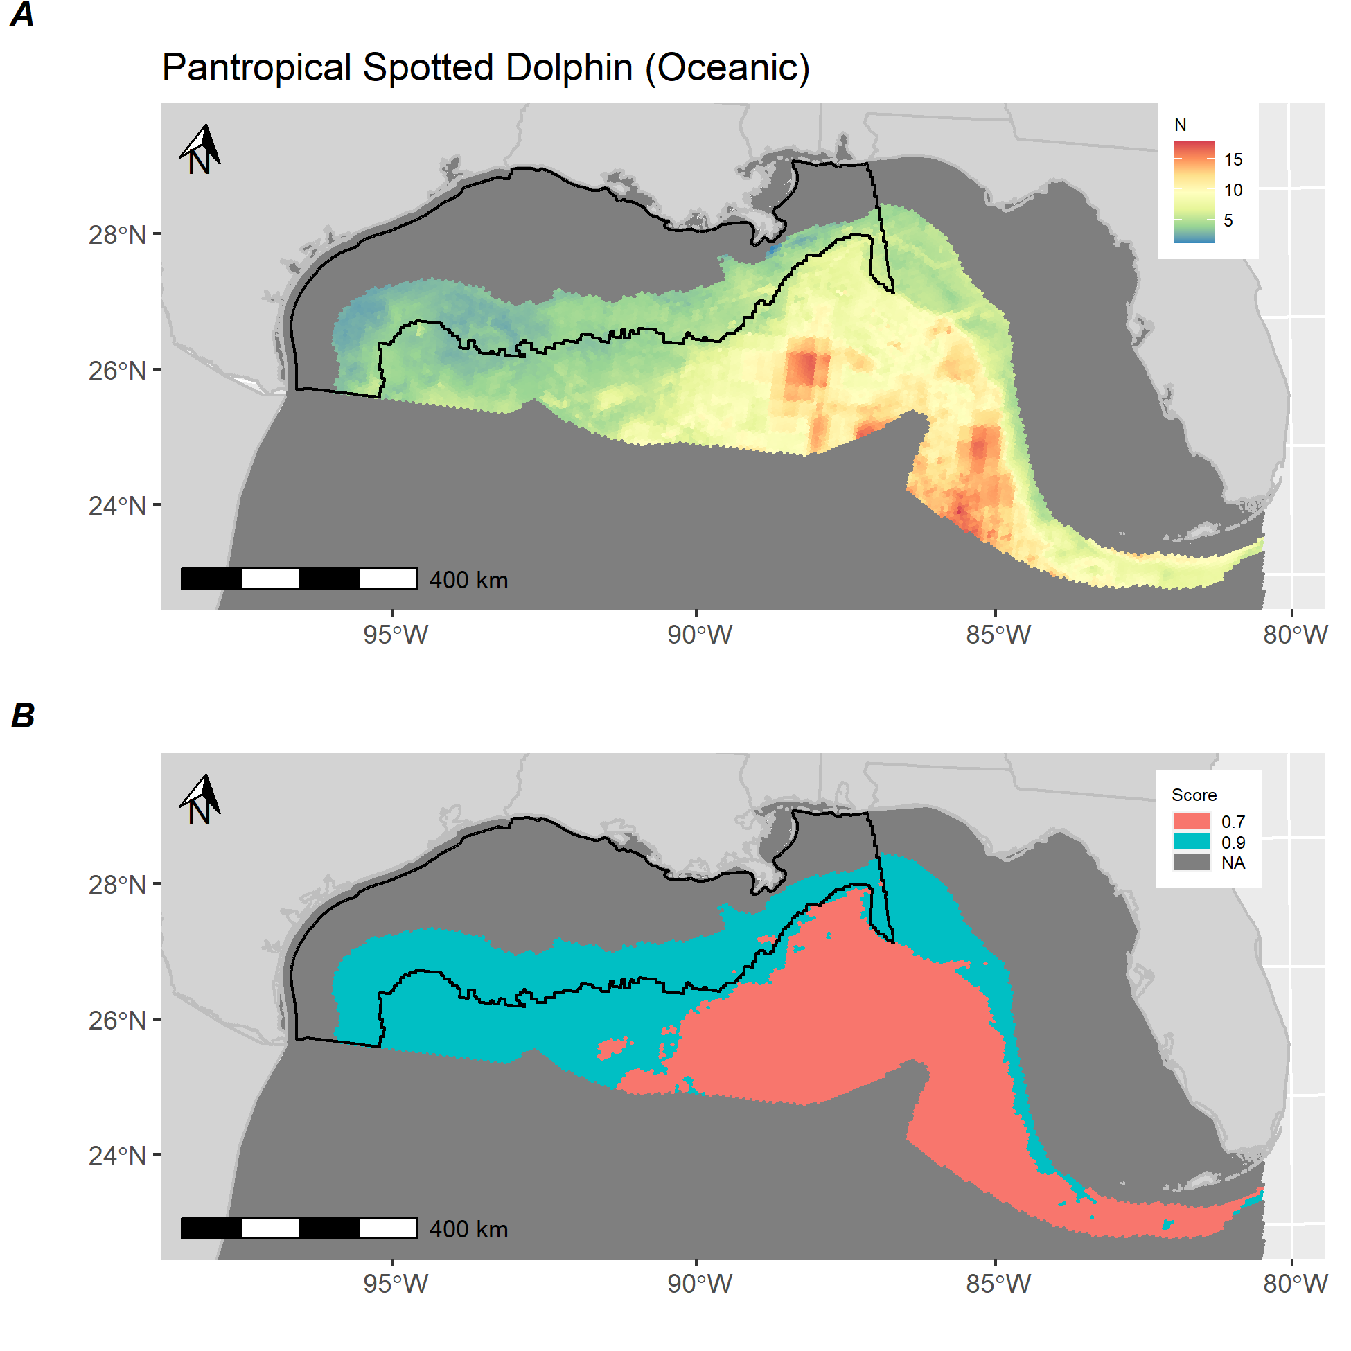

**Figure S-N.** *Pantropical spotted dolphin (oceanic) distribution and score.* A) Estimated abundance of Pantropical spotted dolphin in the Gulf of Mexico based on a species distribution model fit to distance-weighted vessel survey with environmental and bathymetric covariates. B) Calculated score for Pantropical spotted dolphin showing areas above (red) and below (blue) median predictions from distribution model. Black polygon denotes Gulf of Mexico wind energy Call Area.

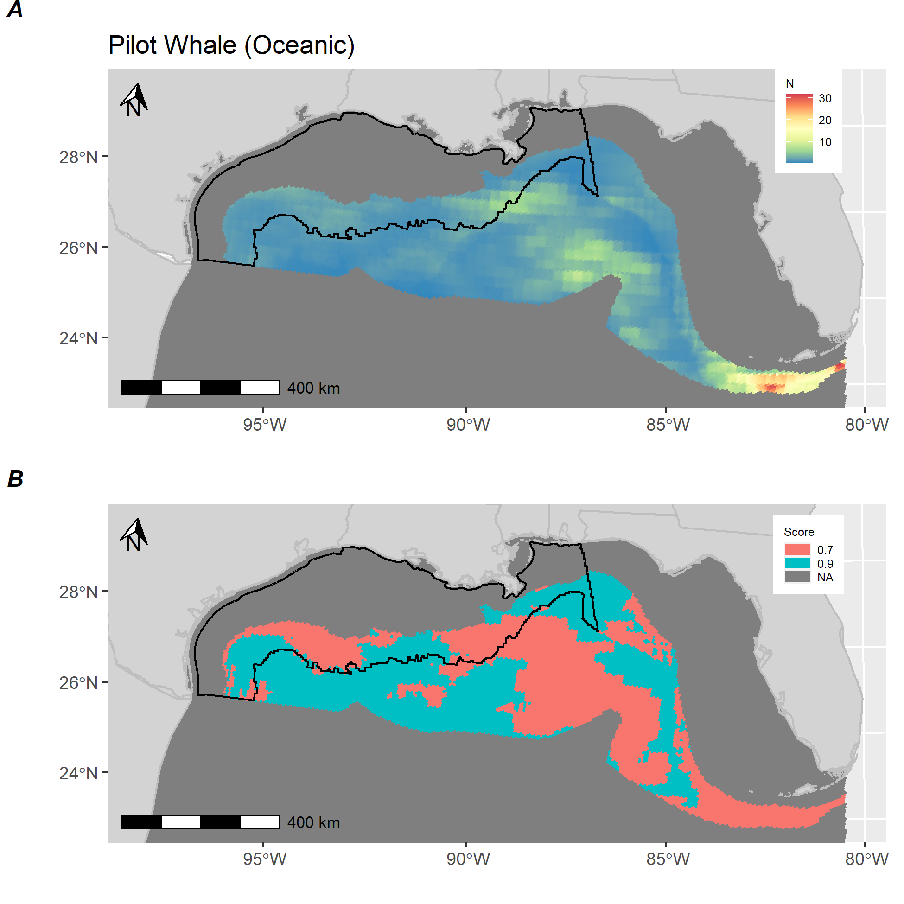

**Figure S-O.** *Pilot whale (oceanic) distribution and score.* A) Estimated abundance of Pilot whale in the Gulf of Mexico based on a species distribution model fit to distance-weighted vessel survey with environmental and bathymetric covariates. B) Calculated score for Pilot whale showing areas above (red) and below (blue) median predictions from distribution model. Black polygon denotes Gulf of Mexico wind energy Call Area.

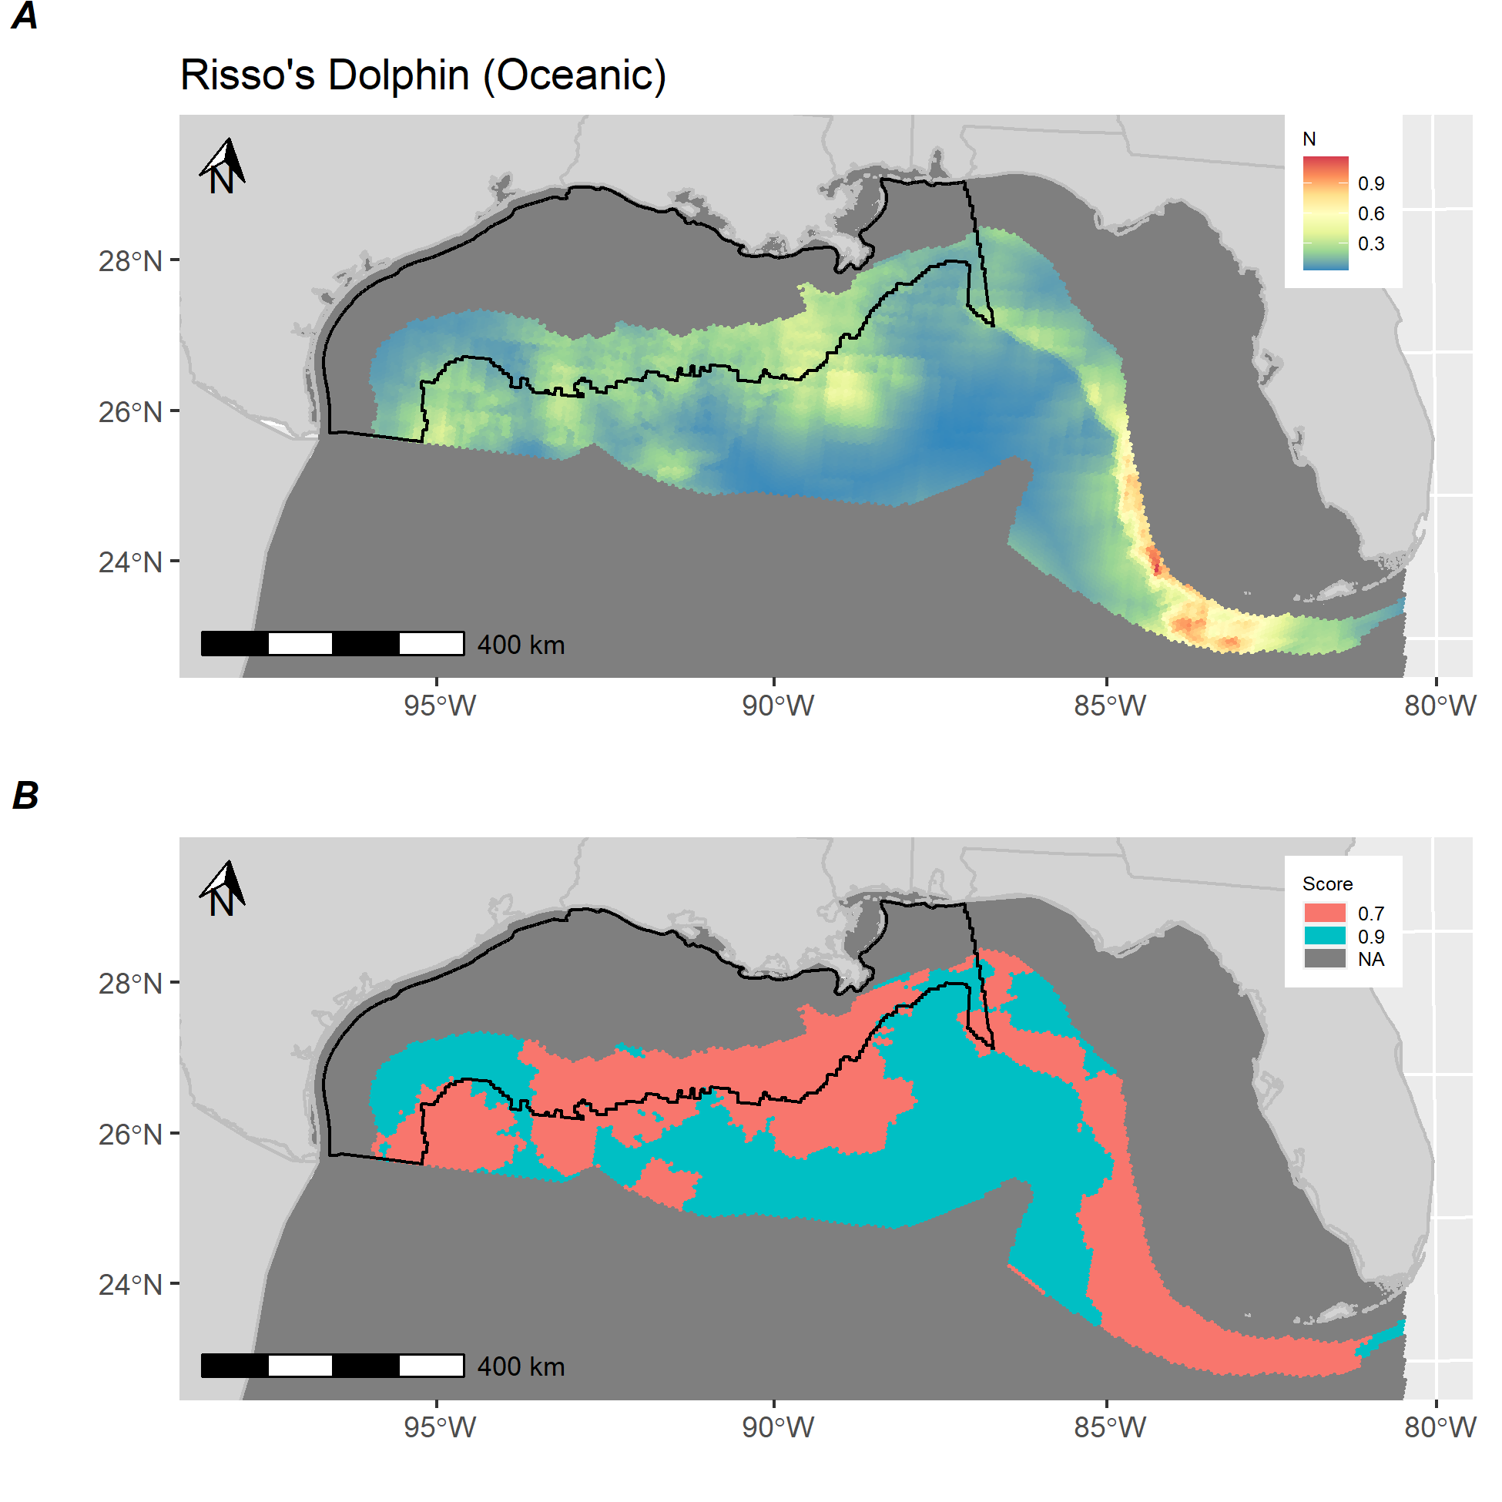

**Figure S-P.** *Risso’s dolphin (oceanic) distribution and score.* A) Estimated abundance of Risso’s dolphin in the Gulf of Mexico based on a species distribution model fit to distance-weighted vessel survey with environmental and bathymetric covariates. B) Calculated score for Risso’s dolphin showing areas above (red) and below (blue) median predictions from distribution model. Black polygon denotes Gulf of Mexico wind energy Call Area.

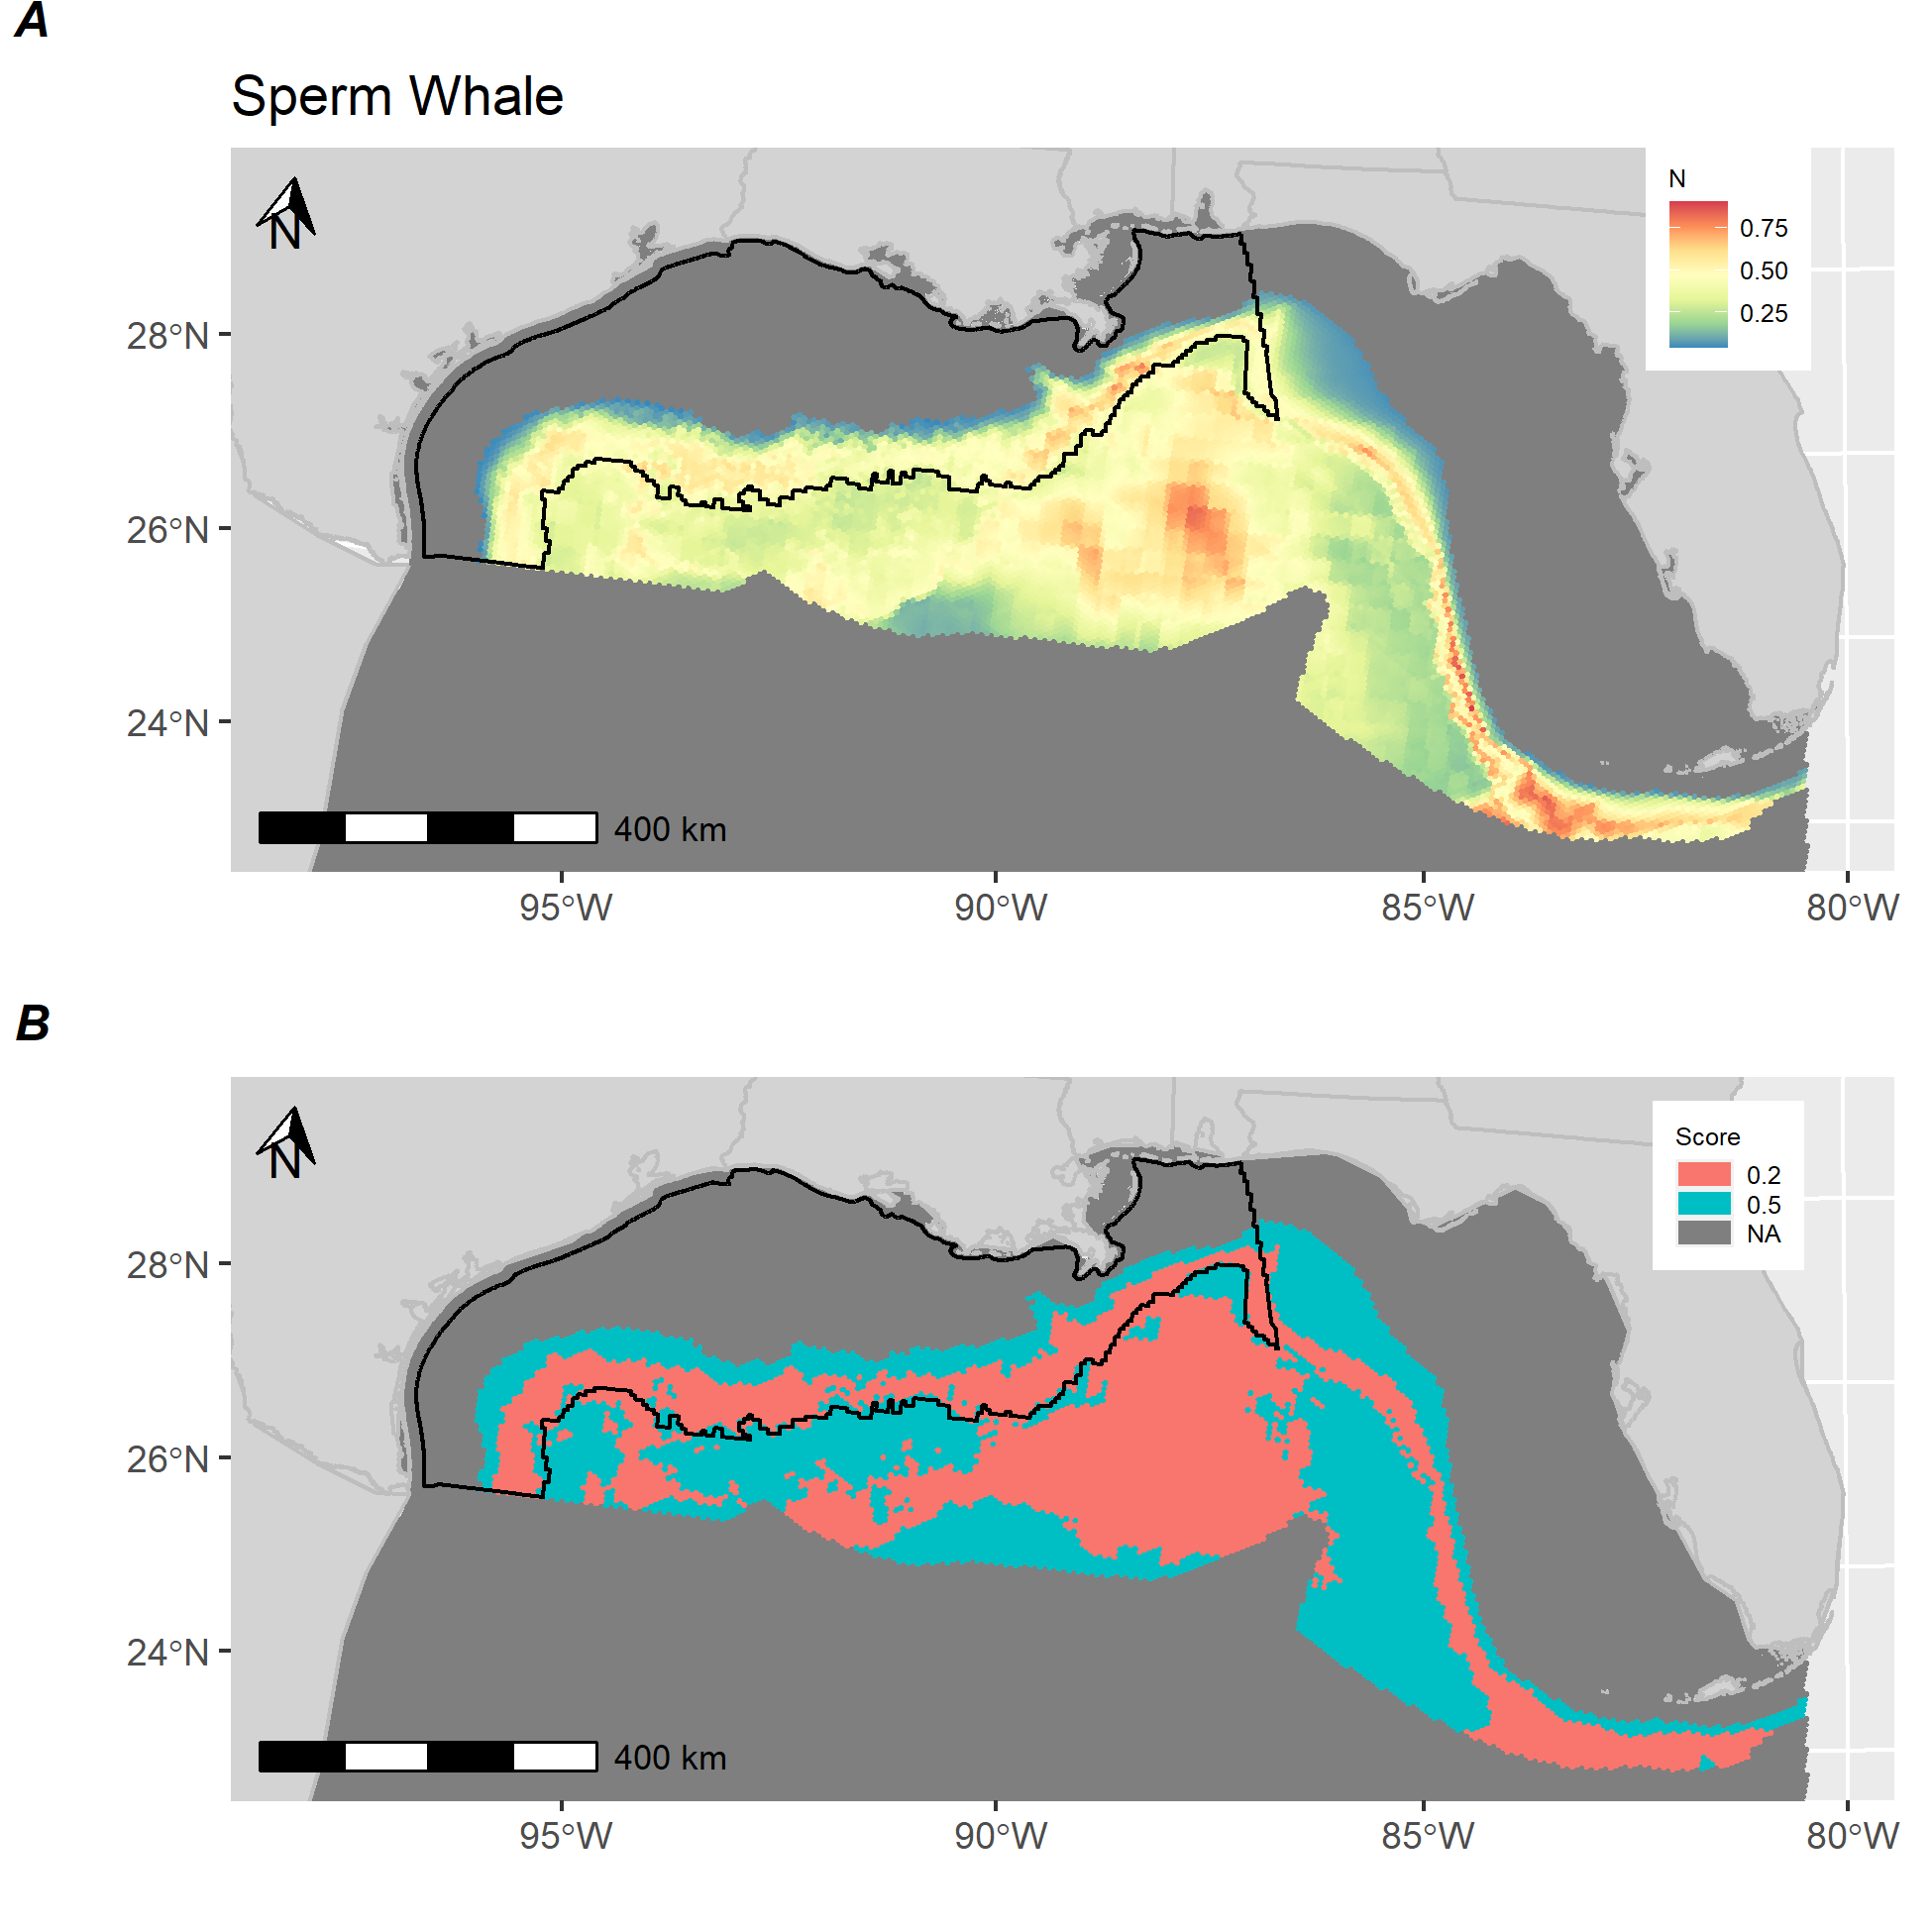

**Figure S-Q.** *Sperm whale distribution and score.* A) Estimated abundance of Sperm whale in the Gulf of Mexico based on a species distribution model fit to distance-weighted vessel survey with environmental and bathymetric covariates. B) Calculated score for Sperm whale showing areas above (red) and below (blue) median predictions from distribution model. Black polygon denotes Gulf of Mexico wind energy Call Area.

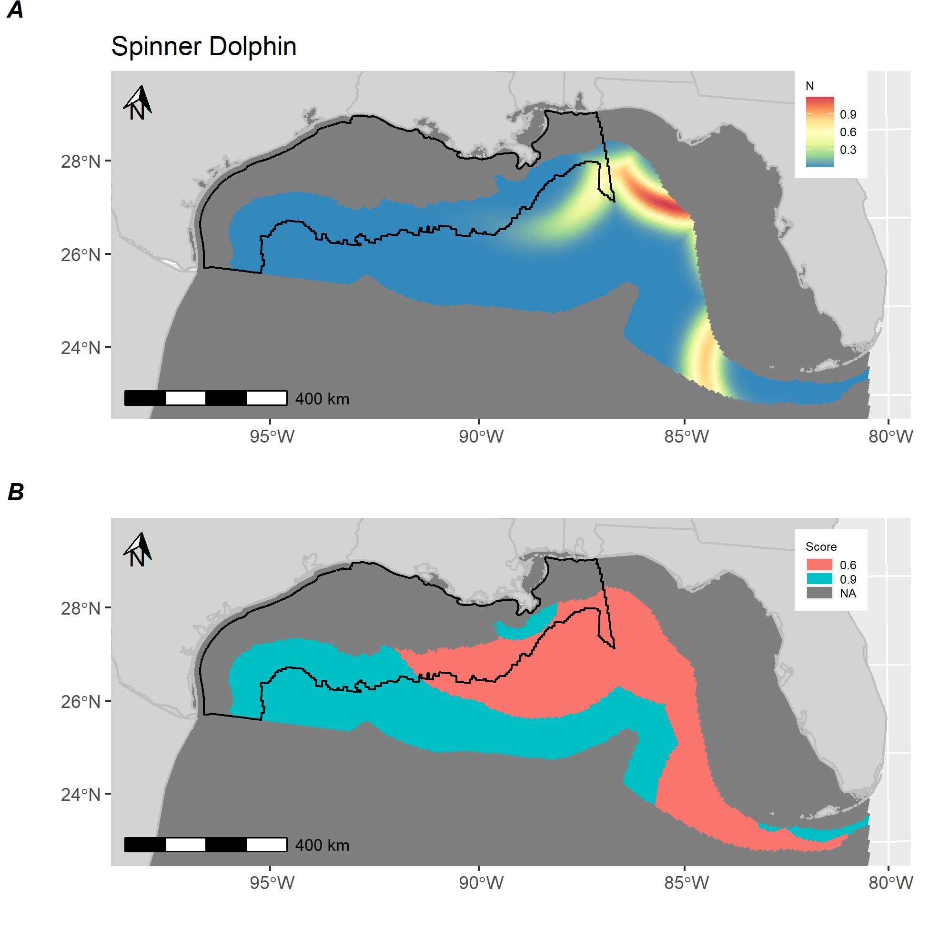

**Figure S-R.** *Spinner dolphin distribution and score.* A) Estimated abundance of Spinner dolphin in the Gulf of Mexico based on a species distribution model fit to distance-weighted vessel survey with environmental and bathymetric covariates. B) Calculated score for Spinner dolphin showing areas above (red) and below (blue) median predictions from distribution model. Black polygon denotes Gulf of Mexico wind energy Call Area.

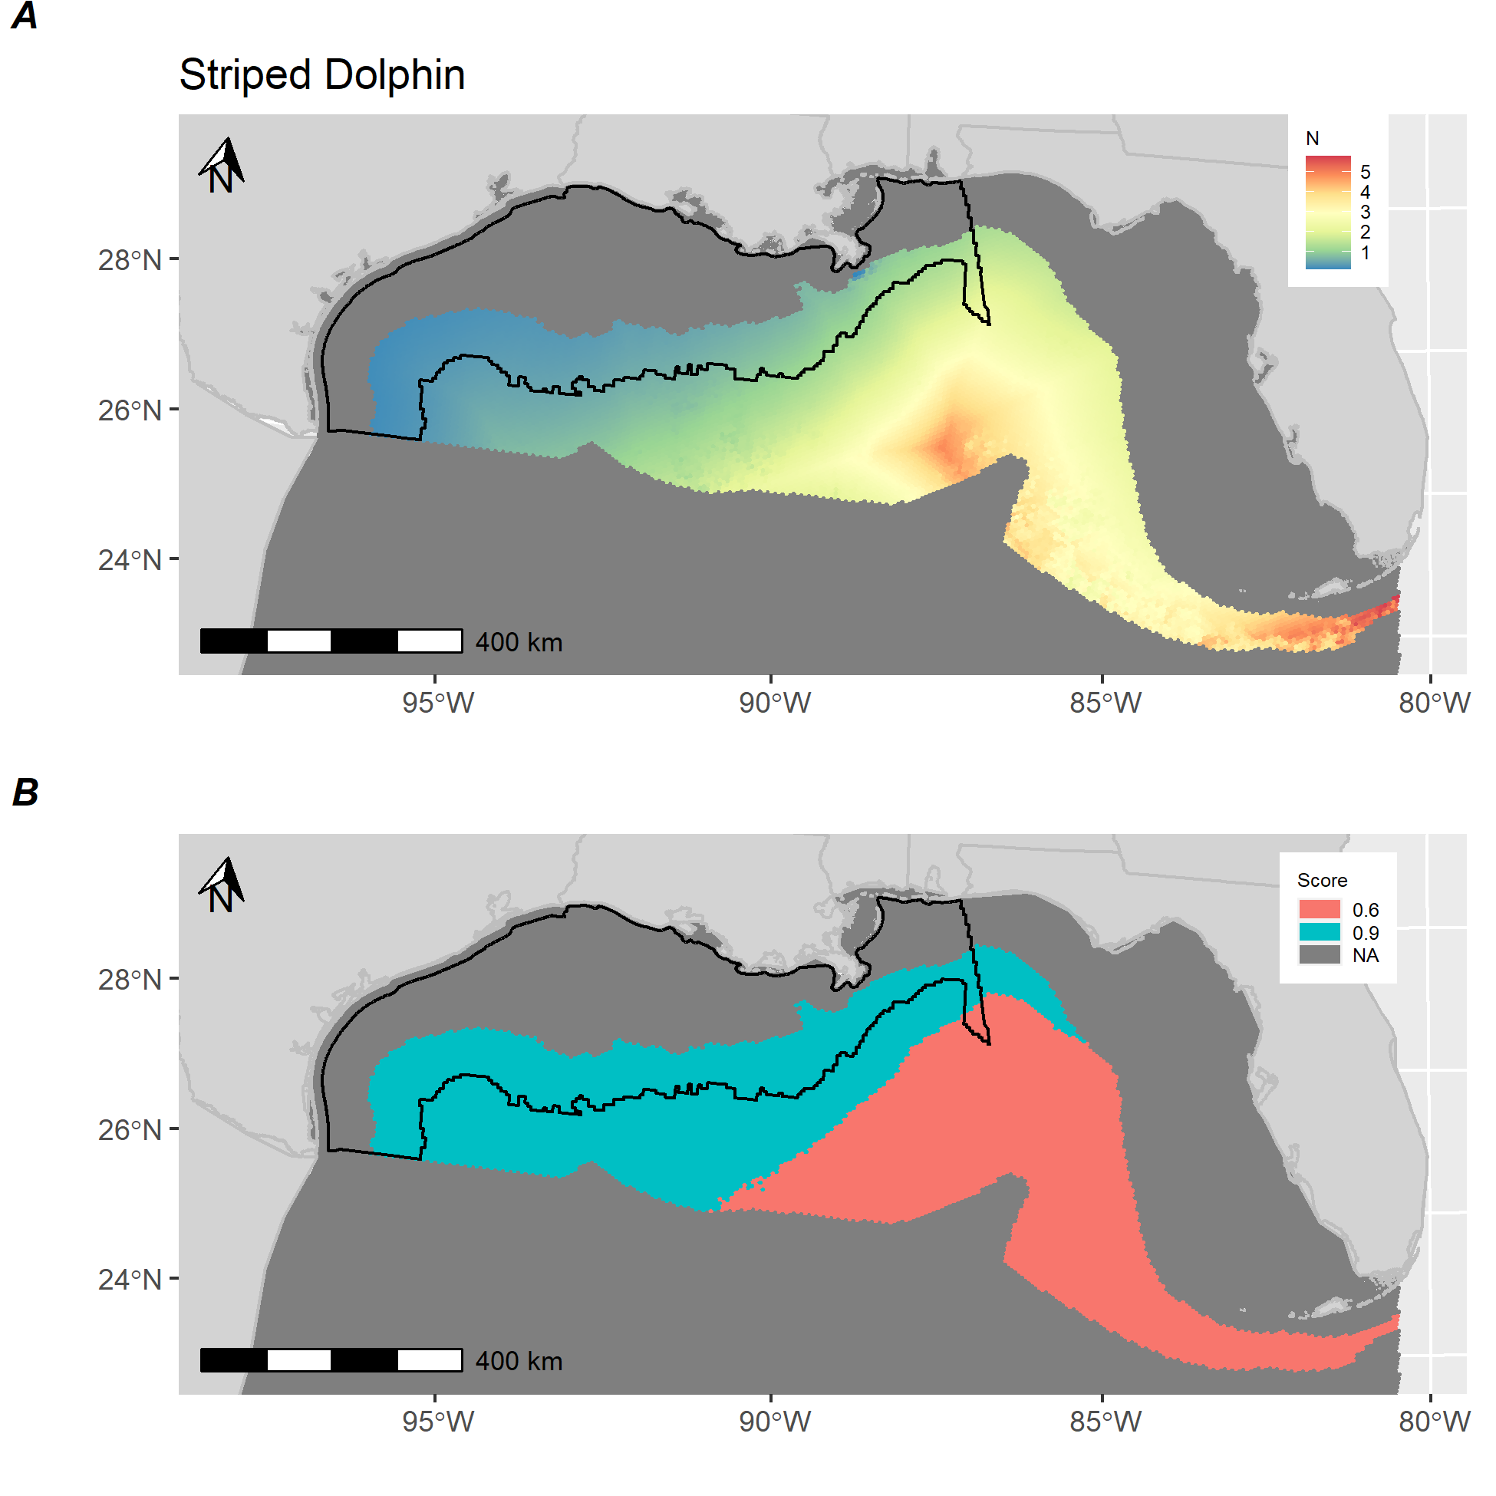

**Figure S-S.** *Striped dolphin distribution and score.* A) Estimated abundance of Striped dolphin in the Gulf of Mexico based on a species distribution model fit to distance-weighted vessel survey with environmental and bathymetric covariates. B) Calculated score for Striped dolphin showing areas above (red) and below (blue) median predictions from distribution model. Black polygon denotes Gulf of Mexico wind energy Call Area.

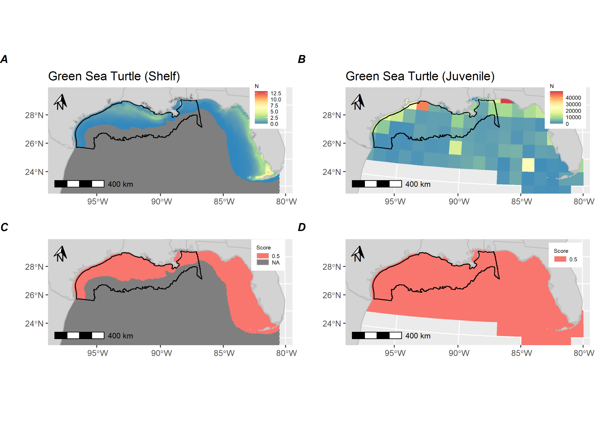

**Figure S-T.** *Green sea turtle distribution and score.* A) Estimated abundance of Green sea turtles in the Gulf of Mexico based on a species distribution model fit to distance-weighted aerial survey with environmental and bathymetric covariates. B) Estimated abundance of juvenile Green sea turtles in the Gulf of Mexico based on Putman et al. (2019) dispersal model. B) Calculated score for shelf adult Green sea turtle showing areas above (red) and below (blue) median predictions from distribution model. D) Calculated score for juvenile Green sea turtle showing areas above (red) and below (blue) median predictions from distribution model. Black polygon denotes Gulf of Mexico wind energy Call Area.

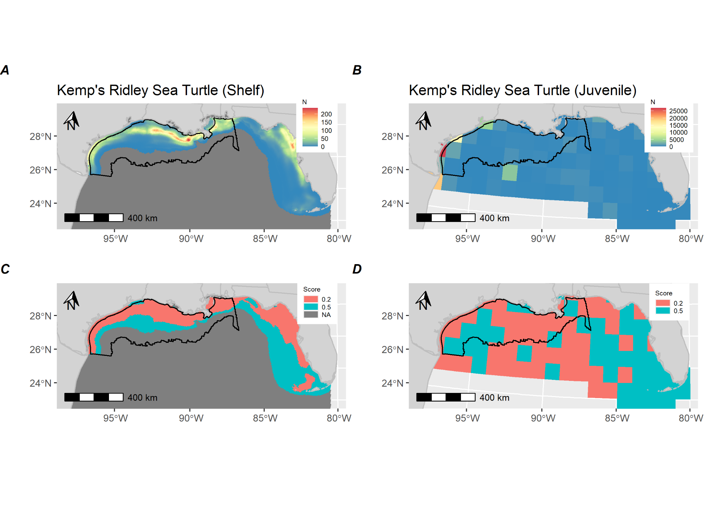

**Figure S-U.** *Kemp’s Ridley sea turtle distribution and score.* A) Estimated abundance of Kemp’s Ridley sea turtles in the Gulf of Mexico based on a species distribution model fit to distance-weighted aerial survey with environmental and bathymetric covariates. B) Estimated abundance of juvenile Kemp’s Ridley sea turtles in the Gulf of Mexico based on Putman et al. (2019) dispersal model. B) Calculated score for shelf adult Kemp’s Ridley sea turtle showing areas above (red) and below (blue) median predictions from distribution model. D) Calculated score for juvenile Kemp’s Ridley sea turtle showing areas above (red) and below (blue) median predictions from distribution model. Black polygon denotes Gulf of Mexico wind energy Call Area.

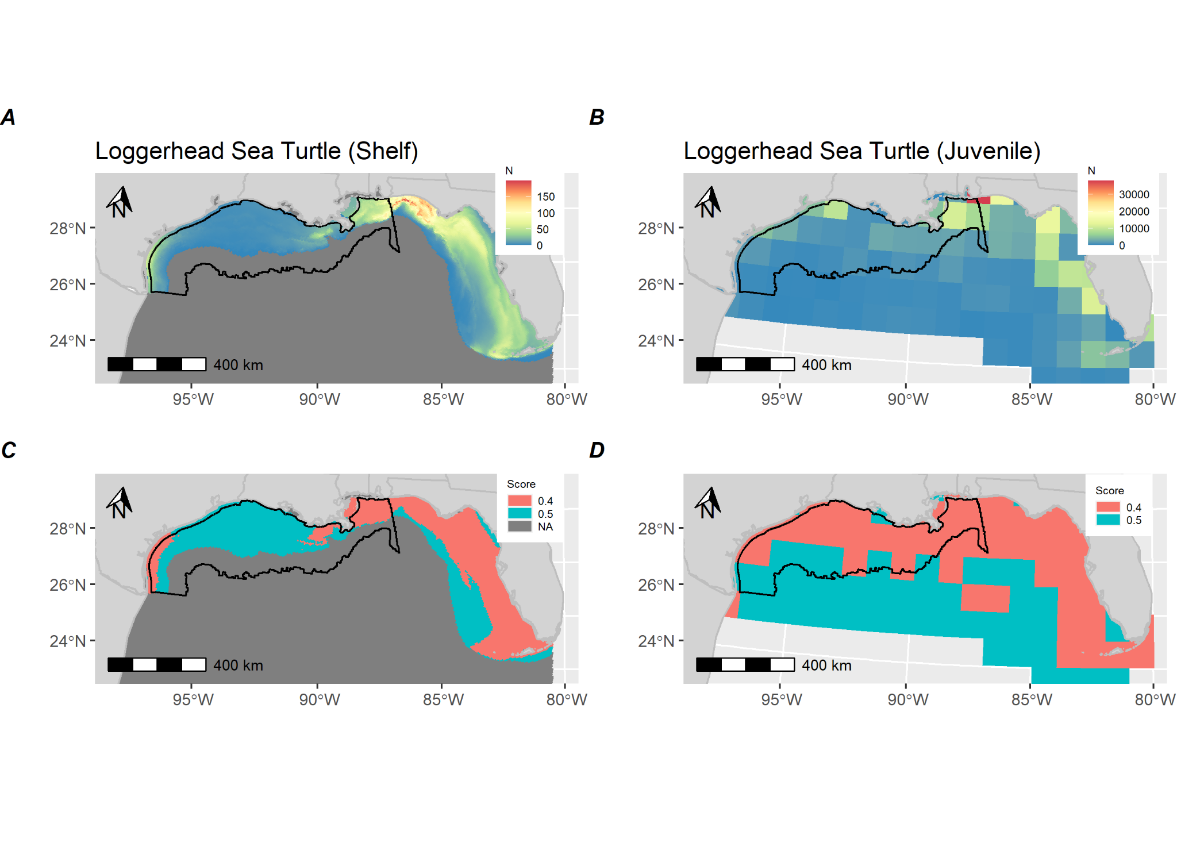

**Figure S-V.** *Loggerhead sea turtle distribution and score.* A) Estimated abundance of Loggerhead sea turtles in the Gulf of Mexico based on a species distribution model fit to distance-weighted aerial survey with environmental and bathymetric covariates. B) Estimated abundance of juvenile Loggerhead sea turtles in the Gulf of Mexico based on Putman et al. (2019) dispersal model. B) Calculated score for shelf adult Loggerhead sea turtle showing areas above (red) and below (blue) median predictions from distribution model. D) Calculated score for juvenile Loggerhead sea turtle showing areas above (red) and below (blue) median predictions from distribution model. Black polygon denotes Gulf of Mexico wind energy Call Area.

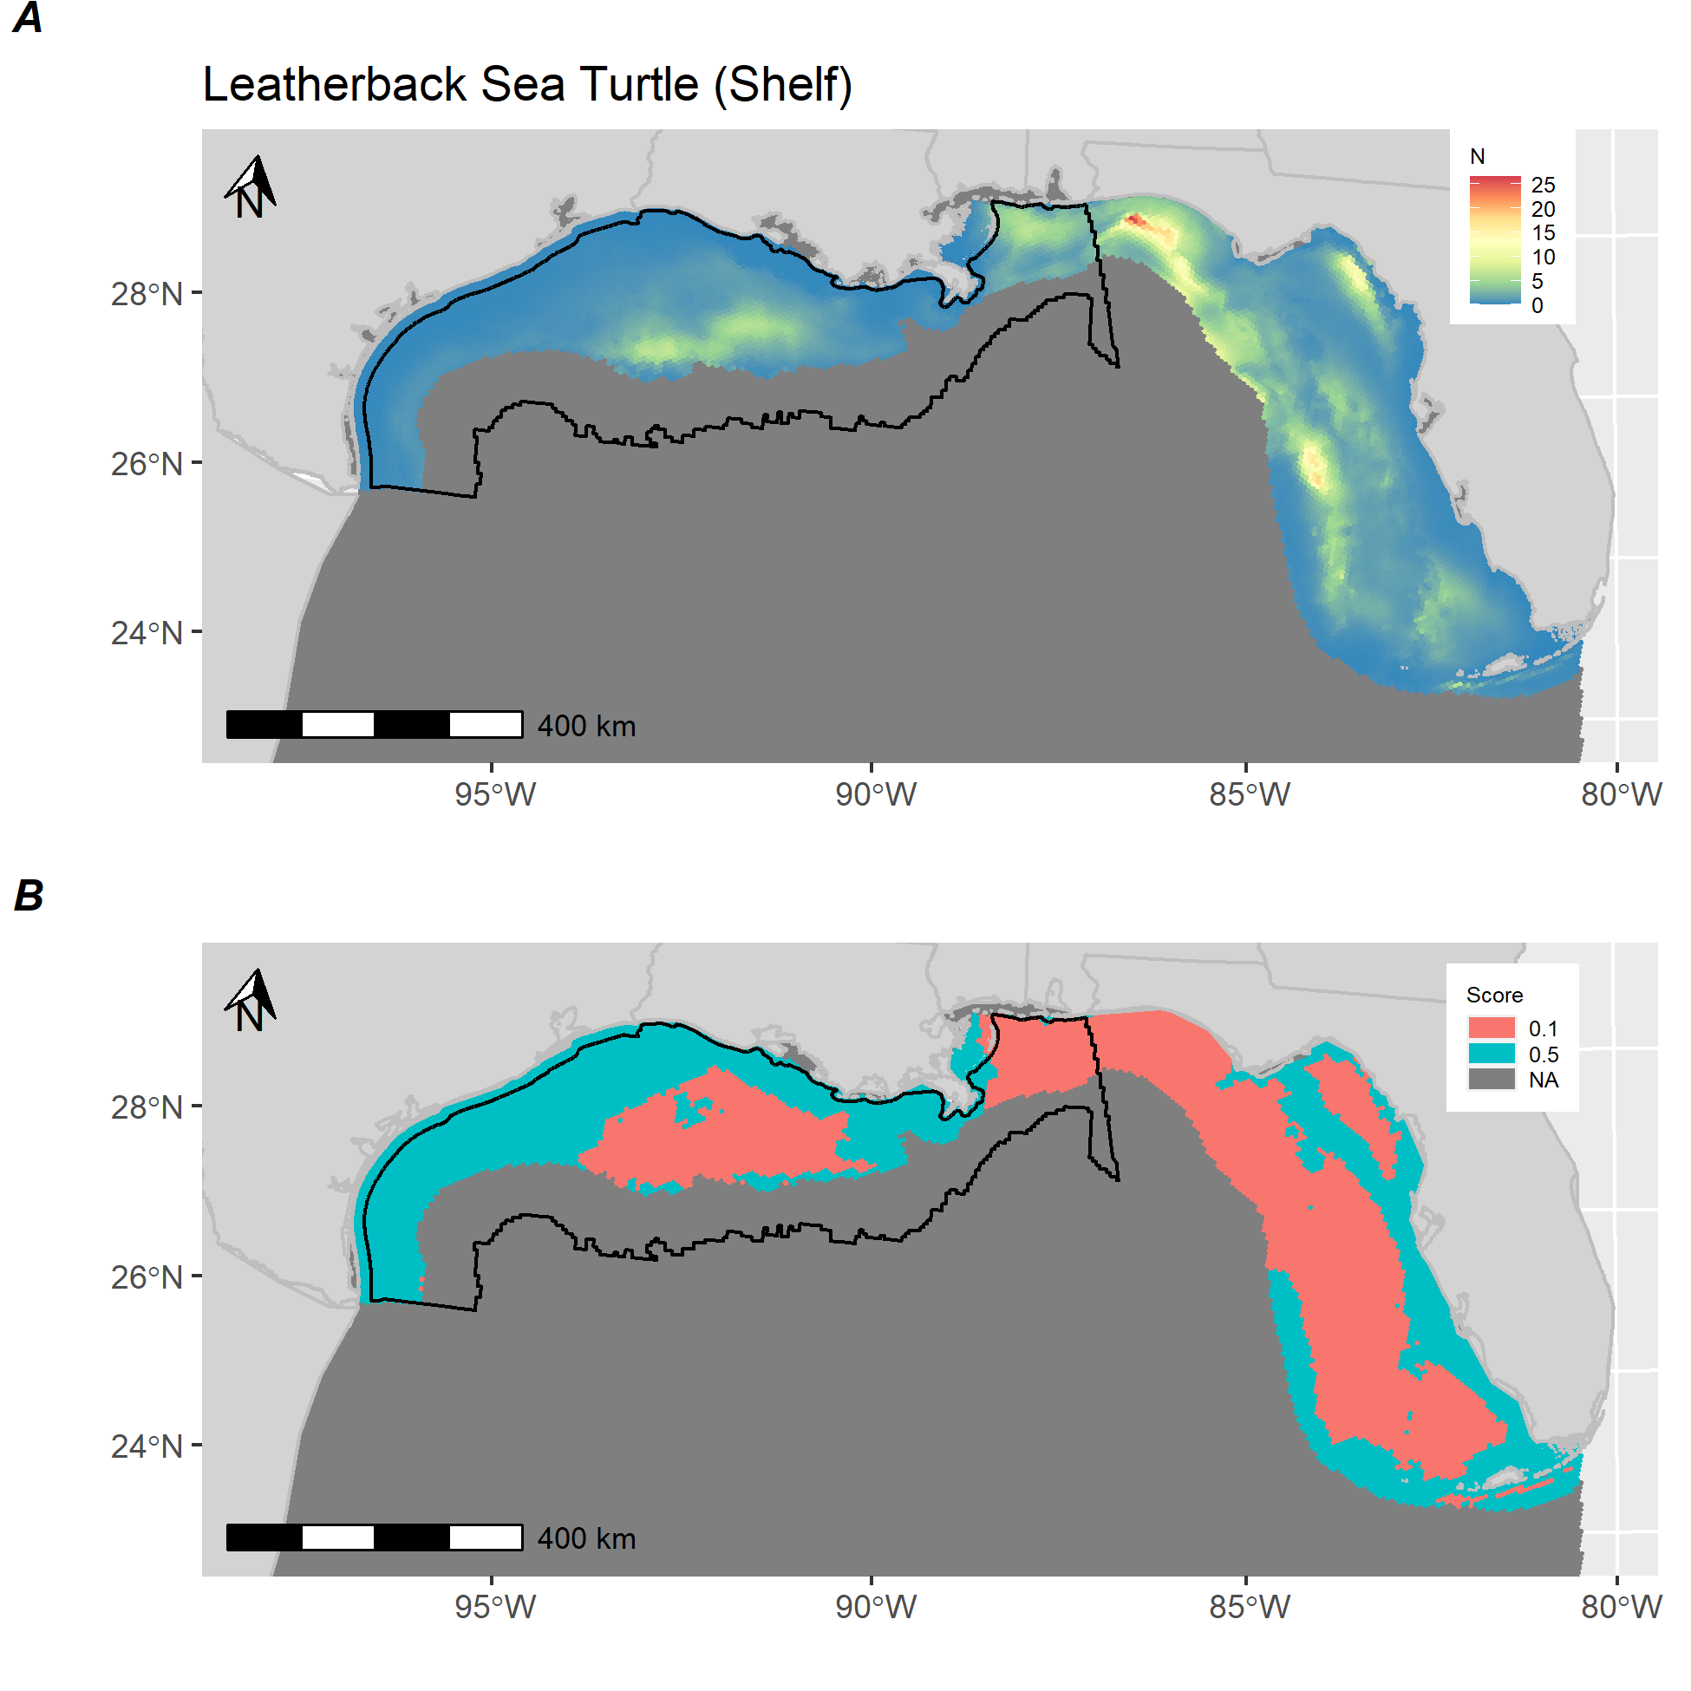

**Figure S-W.** *Leatherback sea turtle distribution and score.* A) Estimated abundance of Leatherback sea turtle in the Gulf of Mexico based on a species distribution model fit to distance-weighted aerial survey with environmental and bathymetric covariates. B) Calculated score for Leatherback sea turtle showing areas above (red) and below (blue) median predictions from distribution model. Black polygon denotes Gulf of Mexico wind energy Call Area.